Voices From Wupatki:

An Oral History Exercise in Decolonization and Indigenization

By Florencia Ruiz Mendoza

To Miriam Mendoza (†), my mother and my star.

To Maurice Platier, my husband, my everything.

“A ghost can only be white-they demanded. -Have you ever seen a ghost?-I asked. I did not want to tell them that I had seen a green ball of energy that could give people pneumonia”-

From Joy Harjo’s memoir. “Crazy Brave”- 2012

“For those who aspire to be free from colonial guilt or oppression, and hold still a dream of belonging, then indigenous oral histories offer a vital key to decolonizing transformations”.

-Nēpia Mahuika.

INDEX OF CONTENTS

Foreword ----------------------------------------------------------------------- 6

Introduction: Hollow Narratives ---------------------------------------- 9

Chapter One: Learning about the Wupatki Pueblos
From the Written Sources ------------------------------------------------------ 18

Chapter Two: Learning about Indigenous Ways of Knowledge---------- 26

Chapter Three: First Nation’s Sense of Place -------------------------------- 33

Chapter Four: Evoking and Connecting with the Ancestors Through the Inter-temporality of Storytelling. ---------------------------------------------- 48

Chapter Five: Indigenous Legacy is American Legacy: Incorporating First Nation Peoples’ Epistemology and Find our Own Sense of Place------- 54

Final Thoughts --------------------------------------------------------------- 64

Acknowledgments--------------------------------------------------------------- 66

Bibliography----------------------------------------------------------------------- 69

Foreword

This thesis was shaped by itself, like a work of literary fiction, it was its own voice the one that outlined the format. Before I started the program I knew I want to do my thesis about Wupatki National Monument and conduct interviews with Native American people of the Southwest. Also, I knew that I wanted to link the practice of oral history to themes of my personal interest like my experience visiting Wupatki for the first time, how to address and discuss a fundamental matter: the foundational myths and official historical narratives in the United States, as well as the presence, representation and acknowledgment of Indigenous narratives and ways of knowledge.

It was of upmost importance for me to discuss the meaning of notions like feeling grounded or not as individuals living on American soil, what places represent us as American people, and what are the landmarks that show the American face to the world.

In the Fall of 2022, when I started the program at OHMA I intended to write a short memoir as my thesis project, I wanted to take advantage of the freedom that students must create our final oral history projects, whether a written work, documentary, diary, capstone, etc. As the program evolved and I gained more theoretical knowledge and technical skills in oral history, such as photography and video editing, I decided that my thesis epistemological and conceptual skeleton will be grounded in the notion of sense of place, after reading Keith Basso’s influential work: “Wisdom Sits in Place”. (Basso, 1996.)

Moreover, I became significantly aware of the importance of letting my narrators’ voices sound, to be sonorous; the aural experience was prime and elemental in my oral history thesis; I was very conscious throughout my journey that the beauty of Wupatki National Monument and the desert of Arizona should not remain in the imagination of the reader. I realized I had to show the beauty of Wupatki, for that reason I considered to make a 15-minute long audiovisual too.

Nevertheless, once I was finished my courses and I had the chance to slow down and being in conversation with my narrators’ interviews and their cosmovision one more time; and after my enriching discussions with my advisor, Mary Marshall Clark, I realized that the voices from Wupatki should speak without the filter of my memoir work or my own interpretation over somebody´s else life, as in a formal academic work was out of any consideration Then, as I stated before, I let the thesis to be shaped in its own terms in order to systematize the richness of my narrators’ storytelling, I concluded that the best way to do it would be through conversations with oral history scholars, especially Indigenous and Native American authors.

Personal memories and personal appreciations of books that I had read previous my visit to Wupatki inspired the introduction of my thesis, so I can say my initial wish of writing memoir is satisfied. This thesis would be incomplete without a general overview of the history of Wupatki, its ecosystem, and the civilizations that built the city and veneered the desert before us. In the first chapter I included a brief summary of the history of Wupatki and its environmental landmarks, like the Sunset Crater Volcano, sacred for Indigenous peoples of the Southwest; chapter two is an exposition of the most influential authors and concepts that discuss the central need to decolonize oral history and western epistemological paradigms.
.
Toward the end of the 2024 Thesis Seminar, I had listened to my interviews at least three times; and after reading OHMA alumni’s thesis and fruitful discussions with Amy Starecheski and my fellow students, I discovered that it was the presence and the evoking of the ancestors in my narrators’ oral histories was indelible from their own reflections on Wupatki National Monument; their storytelling ramified with the time of the Ancestors. I made the connections between my narrators’ storytelling and the permanent union to their ancestors by bringing them to the present continuous. Chapters three and four explored those two core topics, sense of place and evoking the ancestors in the present, respectively.

The fifth chapter presents a few proposals on how to transform and decolonize not only the practice of oral history, but academic research, the paradigms of Western epistemology, ontology and hermeneutics.

Before the reader get immersed in the past, the history of Wupatki and Indigenous’ storytelling, I want to express my gratitude to my narrators for this journey of knowledge, humility and reverence to the land, to the site.
Respectfully.

Florencia Ruiz Mendoza
New York City, September 2024.

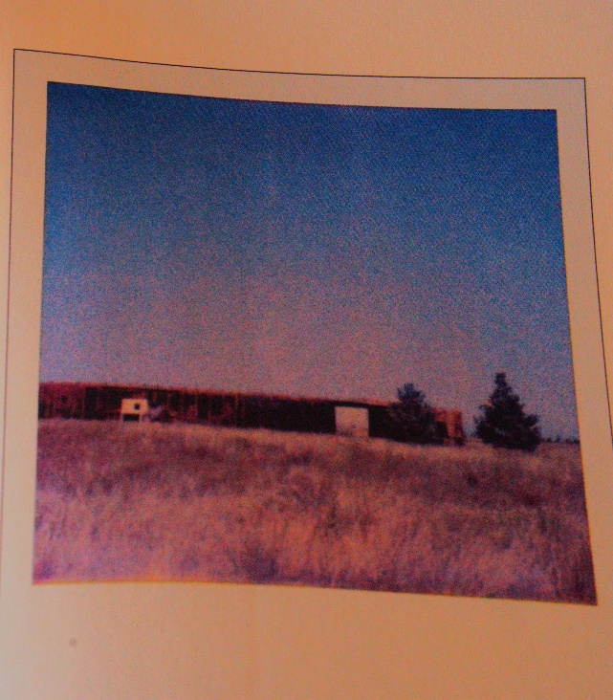
Lost Children Archive Picture, Valeria Luiselli.

Introduction: Hollow Narratives

“Myths hold people together and give people a direction. We may say America is socially fragmented, and we may be people without a myth.”

-Robert Berner, American Myth: Old, New, Yet Untold, 1995.

This journey started before I applied to OHMA. It started in the summer of 2021; my husband and I planned a trip to the Grand Canyon and other regional landmarks. Thus, I started planning a journey to the American Southwest. Previously, I had read Lost Children Archive by Valeria Luiselli and Alvaro Enrigue’s novels Ahora me Rindo y Eso es Todo (Now, I Surrender and That is it) and Hypothermia. Inevitably, planning that trip to the Southwest was permeated by the echoes of Luiselli’s and Enrigue’s novels, which eventually became the core ideas of my oral history project: Voices from Wupatki: An Oral History Exercise on Decolonization and Indigenization. Enrigue and Luiselli are Mexican-born writers who have written extensively about the United States and the American experience.

Alvaro Enrigue reflected on the fact that everything, every people, and every nation included in the European chronicles, were erased automatically from the face of the Earth, from the face of our memory. (Interview with Alvaro Enrigue, New York, 10/28/ 2022). The following clip will better convey Enrigue´s ideas about erased people, events, and memory. And will illustrate, perhaps, the core premise of my oral history work.

1 Enrigue.mp3

Lost Children Archive (2019) is a groundbreaking literary work about the children who traveled alone and undocumented to the United States through Central America and Mexico. The author, Valeria Luiselli’s novel, was inspired by her personal experience as a volunteer interpreter between undocumented minors seeking asylum and U.S. government agents in 2014. In her novel, Luiselli explored other significant topics she encountered in her own journey to the American Southwest, such as American borders and foundational myths.

When I started reading Lost Children Archive (2019), my attention was focused on the children’s crossing along the American continent. However, Luiselli’s novel addresses the historical narratives that involve the foundational myths of the United States of America. Lost Children Archive (2019) focused on a pivotal moment in American history: In 1830, President Andrew Jackson proclaimed the Indian Removal Act. Cochise was arrested in 1861, and Geronimo in 1866; the latter spend 23 years of his life as war prisoner, after being released he died of pneumonia in Fort Sills, Oklahoma. Cochise and Geronimo symbolize the last stronghold of resistance, not only of the United States but, perhaps, the latest in the American continent. As a Mexican, that was highly profound as it is part of my history because we are talking about the last cluster of rebellion against colonization in the United States and the Americas.

Cochise and Geronimo represent in popular memory the last Apache Indians to be defeated and who resisted vehemently the attempt of physical and ideological extermination that the U.S. government made against them. This quote reflects Geronimo’s way of thinking: “"It is my land, my home, my father's land, to which I now ask to be allowed to return. I want to spend my last days there and be buried among those mountains. If this could be I might die in peace, feeling that my people, placed in their native homes, would increase in numbers, rather than diminish as at present, and that our name would not become extinct." (Barret, 2016, p. 105) ; that was the culmination of the White people’s colonization project that started in 1607 when they arrived at the Atlantic coast of what today we call Virginia. The tragic and unbearable irony is that the first dwellers of this land turned out to be the enemy, the “Red Evil” who opposed progress (Berner,1995). In the following century, Westerners’ films portrayed the Apache Indians as the enemy, as evil and uncivilized, and image was transnational, as a natural consequence of fake narratives dissemination outside the United States.


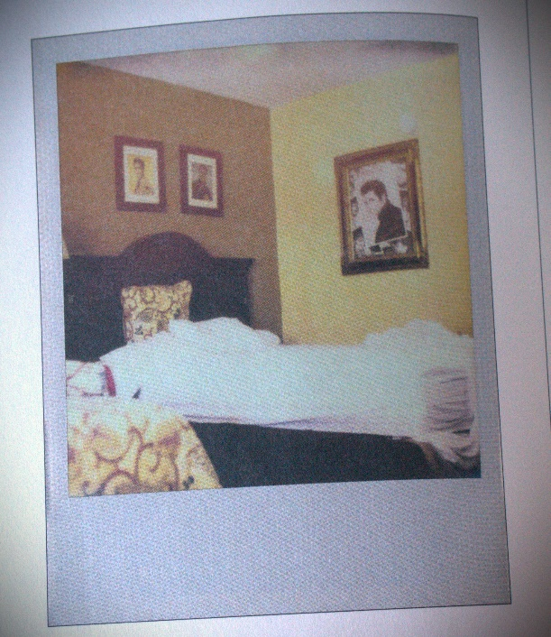
There is a scene in Lost Children Archives (2019) where the protagonist's family, a couple with two young children, had just arrived at Graceland; they were resting in a motel on Elvis Presley Boulevard Inn. The pool had the shape of a guitar, and inside the room, there was a portrait of Elvis Presley hanging on the wall. The ten-year-old boy claimed: “Is that Jesus Fucking Christ!?. No- his mom answered that’s Elvis Presley” (Luiselli, 2019, p. 104). What my mind distilled from that scene was Luiselli’s intention to juxtapose national symbols, elevating, in this case, Elvis Presley to Jesus Christ himself! The conversation with the book drove me to think of other national symbols or ports of entry to America herself and her culture, such as the Statue of Liberty or Elvis himself.

As a reader, I think Luiselli meant that Americans are prouder of Elvis Presley and his music than the Native American heritage, which certainly does not belong to the foundational myths of this nation. The Statue of Liberty is more meaningful to American people regardless of their identity and their background than any pre-Columbian archaeological site. Who is the one who does not need a prefix in their Americanness? As opposed to an African American, Mexican American, Chinese American, or Arab-American? Isn't the Native American the real American?

As I planned my first trip to the Southwest in 2021 and saw the images on the brochures, like white families enjoying holidays all over Arizona, New Mexico, and Utah, it became very evident to me what Valeria Luiselli addressed: the conquest of the American West, an immense territory that was emptied, evacuated, and whose people were evicted so the white settlers would benefit from it and enjoy the land.

Wayne Hare remarked in his essay “If You See Racism Call It Out” (2021) that despite the initiative in Utah to remove the word “Dixie” from state institutions, he always sees in ads, especially on skiing advertising, pictures of white happy people. I agree strongly with Mr. Hare. I remember that almost all pictures of recreational activities in the Southwest showed smiling white families with glittering eyes in their online brochures. I also remember my deep sadness. One day, I understood that for my own sake, I had to deal with the defeat, to deal with the meaning of war privilege; it is the law of war, earned by “the victors of the war on the territory,” therefore it is a white family who exerts the right or privilege to be in the picture of the brochure. To whom belongs the United States? What can I do to counter the effects of a history I cannot undo?

I went on that trip under the assumption that American people are more fixated on cultural elements such as the Statue of Liberty and Elvis Presley than on our Native American heritage. Perhaps one of the most haunting questions Luiselli has asked is: How can we tell the missing voices? By what means do we tell a story from its very beginning?

My Journey to Wupatki National Monument and the Grand Canyon

At the Grand Canyon National Park bookstore, I bought a book titled I Am the Grand Canyon. (2006). On its cover, there was a Havasupai man. Until that day, I was completely oblivious to the Indigenous people who have dwelled down in the Grand Canyon for centuries; until that day, I only had heard a fake narrative that erased the history of that ancient Nation that populated the North America more than 23,000 years ago. The narrative I was told was about the first White explorers who arrived at inhospitable and inhabited lands where “no human foot had stepped on that country ever.” I wondered if the history of the Havasupai is taught in elementary schools across the United States…and my answer was no.

I still remember the nitid images I saw of the Wupatki Pueblos, a Native American archaeological site one hour away from Flagstaff by car. I knew I wanted to go there, as I had never visited a Native American archaeological site in the United States before. The red color of the sand on the Wupatki Pueblo bricks invited me vehemently to visit the site. The rocky redness of the Arizona desert vibrated on my computer screen.

I resolved to go with my husband to Wupatki because I had discovered traces and clues that guided me to the American Southwest to look for sites of memory, of concealed and erased memories from dominant history narratives. I had been impressed before by images of Mesa Verde in Colorado and Montezuma Castle, Arizona many years ago; Wupatki was accessible from the Grand Canyon South Rim.

Visitors will see the Sunset Crater Volcano National Park entrance fifty miles from Flagstaff, Arizona, en route to Tuba City. It is worth mentioning that most tourists drive over there to see the volcano, and sometimes, they drive out of the way to see the Wupatki Pueblos. In my case, it was the other way around.

It was impossible to take our sight off that surreal landscape, packed with dunes covered with ashes; loose black dust was everywhere, and the hills looked like millenary ash deposits. Now I know Sunset Crater Volcano is a textbook of the Earth, as it allowed geologists to discover what happened on our planet 200 million years ago (Thybony, 1987). I knew we were driving into a passage of time as soon as I walked out into the desert of the Wupatki Pueblos; unlike most of the archaeological vestiges in the southwest, which may be located inside cliffs, Wupatki National Monument was constructed in the wide-open desert, under a blinding sun, where temperatures rise above 110 degrees and miles of dry land dominating the landscape (Thybony, 1987). Nothing but the red and orange sands that make the landscape so beautiful. Wupatki National Monument was constructed on the border of the red sand soil and the black ashen hills.

Unfinished Stories, Unfinished Journeys

American history and its foundational myths are unfinished if we do not include the Indigenous story as part of our historical and foundational narrative. However, where are the Indigenous narratives? Luiselli and Enrigue addressed this very well: the story is incomplete. Something essential and fundamental is missing from the beginnings of the American nation.

In Hypothermia (2005), Alvaro Enrigue made visible the destiny of the Indigenous of this country after the white men finally conquered the West: Native American people disappeared or had to assimilate. Assimilation is the only alternative that the system imposed over peoples; the ruling historical narrative of the United States of America is the narrative of the British colonizers for the dawn of America is traced back to the ships coming from the East, sailing off from Europe, with European immigrants, dreaming of a land of liberty for the white immigrants and their supremacy. That narrative demanded an empty land, as Christians do not assassinate their own kind, not even “the savages”. Both, Spanish and British and other European colonizers erased the Indigenous populations with their pens. Nobody wants to be regarded as the murderer, not even the murderer.

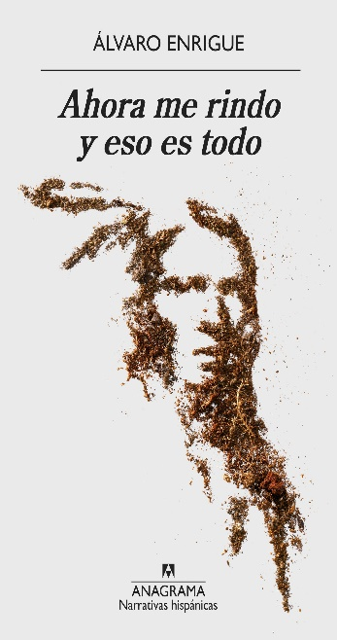
Alvaro Enrigue wisely observed in his novel Ahora me Rindo y Eso es Todo (2018) that the human brain does not have the capacity to remember the future. Nevertheless, the mind compensates for this deficiency with the gift of traveling backward into the past; we remember and can reconstruct the myth thanks to memory. “We never know what the story is about until we finish it; not even writers know the end”(Enrigue, 2018, p.113). Memory is the antidote to filling in the voids in the past.

Polyphony of Voices

I thought of the polyphony of voices inspired by Luiselli’s ideas; she conceived a polyphony of voices thinking of the immigrant children in the Lost Children Archive. (2019) I also wanted to create a polyphony of Indigenous voices, Hopi, Navajo, Zuni, Apache, and more, that spoke about Wupatki and explore their relationship with the site. I also wanted to honor the land and the experience of having been at Wupatki in the heart of the desert.
Valeria Luiselli accurately said that borders divide and connect two nations simultaneously. My oral history project, Voices from Wupatki, always pretended to connect, or better said, to reconnect, borders through Indigenous storytelling.

Hopi oral tradition traces its origins in Palátkwapi, where the Hopi people tell it was in central or southern Mexico. Moreover, the Mexicas (or the so-called Aztecs) claimed their ancestors, the Aztecs, came from a place called Aztlán, somewhere in North America. Western epistemology locates Indigenous oral tradition in the mythical tale category, but as Māori scholar Nēpia Mahuika stated that oral tradition and myths are part of the historical narrative for Indigenous people.(Mahuika, 2019) From this argument, I was inspired to create a project that explored where American history, its narratives, and foundational myths relied on.

The Voices from Wupatki: Moving Forward Toward the
End of the Journey

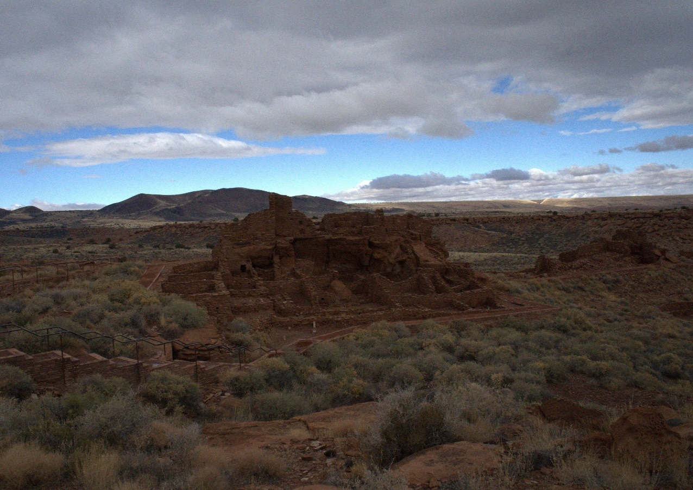
Wupatki Pueblo, Arizona.

The history of our country does not begin with the European settlers arriving on the Mayflower ship. North America was populated for over 23,000 years (Brandt and Smith, 2013) and the intercultural exchange was continuous. The Wupatki pueblos tell us a fascinating story of humans dwelling in the area, about peoples who walked across it, and reached the Grand Canyon, where thousands of small shrines hundreds of years old have been found, as well as trails between the Grand Canyon and Wupatki National Monument.

Wupatki National Monument is portrayed on the web as a beautiful place to visit, a promising place for wonderful vacations, and a landmark people should not miss during their skiing journey to Snowball, in Flagstaff, or during their new-age retreat in Sedona, Arizona. Nonetheless, Wupatki has maintained its cultural and historical heritage among Indigenous people. For centuries, many civilizations, such as the Anasazi, the Sinagua or Ancestral Puebloans as they are referred today , the Kayenta, Havasupai, Zuni, Piaui, and many others, dwelled in those whereabouts, worshiping the spirits that surrounded Wupatki and landmarks of the ecosystem, like the Sunset Crater Volcano. Infinite voices surround those sites of wisdom, knowledge, and healing.

At first, I did not know how to merge in my research what I had learned in Valeria Luiselli and Alvaro Enrigue’s books about foundational myths, hollowed historical narratives, peoples, and civilizations who had been erased by the pen of the white men, among other relevant topics. I also wanted to merge my experience in the American Southwest and incorporate it with questions like grounding, Indigenous storytelling, and Indigenous sites of memory that challenge such powerful iconographies that derive from images like the Statue of Liberty in New York City. Finally, it seemed to me that a great port of entry to start this conversation would undoubtedly be the archaeological site of the Wupatki pueblos and find out what Native American people had to say about that.

Chapter One: Learning about the Wupatki Pueblos From
the Written Sources

Wupakti_National_Park-4K-3.mp4

Many civilizations and ancient peoples lived in what we call the American Southwest today. Those peoples arrived on the land more than 25,000 years ago, where there was intense cultural interchange among civilizations. Nevertheless, particular conditions allowed the building and dwelling of the Wupatki Pueblos, particularly after the Sunset Crater Volcano erupted.

The more I learned about Wupatki National Monument, the more it reminded me of Teotihuacan, one of the most significant archaeological sites in the Americas, situated in Central Mexico; both were important centers of cultural confluence and interchange, both sites were well connected through trails. In fact, there is evidence of trails between Wupatki and the Grand Canyon. The Grand Canyon is home to thousands of shrines demonstrating indigenous people's millenary presence.

Wupatki National Monument is in the heart of Sunset Crater Volcano National Park. Scholars have remarked that Wupatki was built for us in the open desert, unlike other cliff dwelling sites in the region like Walnut Canyon and Montezuma Castle. There are six pueblos (archaeological structures) in the Wupatki archaeological site; those pueblos are separated by a few miles between them and distributed in a loop. The largest pueblo is Wupatki, which means “Tall House” in Hopi. Wu Koki is the second largest construction, meaning “Big House.” Further away, there are two constructions: the Citadel and Nalakihu, Lomaki (beautiful house), and Box Canyon.

The Wupatki Pueblos represent a unique settlement of farming in the history of the Southwest (Stanislawsky,1963). According to traditional archeology, the Wupatki pueblos show a variety of architectural styles that suggest the existence of far influences like the ball court, the kiva (or Amphitheater), and a blowhole. All those structures somehow are traced back to Mesoamerica; those Mesoamerican traits influenced places like Chaco Canyon in New Mexico and Mesa Verde in Colorado. Ball Courts are also associated with the Hohokam and the Mogollon culture, and the consensus is that the ball courts were an influence and adaption from the ones in central Mexico. (Anderson, 2021 p. 5)

The Sunset Crater Volcano

Sunset_Crater-4K-4.mp4

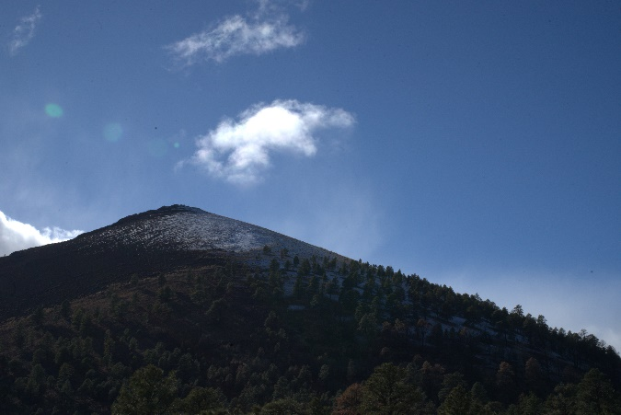
Nature shapes human life, and human life adapts to it. The Western world named it Sunset Crater Volcano, for its crater lights up in red and orange tonalities at dawn as oxide cinders fall around the rim. The history of the landscape tells us that the Sunset Crater Volcano exploded around 1064 A.C, and ashes contributed to the formation of fertile soil. Archaeological research suggested that the Anasazi, the Cocohina (the Hopi word for the Havasupai Nation), and the Sinagua or Ancestral Puebloans peoples inhabited and abandoned the area in 1225. The soil became a lot more fertile, and human life throve. Nevertheless, there is a debate about whether there was or not human dwelling during the eruption of the volcano; supposedly, archaeologists found evidence of previous housing. The predominant vegetation in the region is the Ponderosa trees. However, according to scientific data, those trees have been there for only 400 hundreds: it is paramount for Indigenous people to research the preexisting vegetation (Stoffle & Van Vlack, 2022).
1The Volcano
2 The Sacred Volcano or Polotsom.

The Hopi people refer to it as Polotsóm or Red Hill, the Havasupai as Ña Ñwa or the “Sun’s House,” the Western Apache as “What it Burnt” or ko’ ha godi’ ‘ hi’ ka ‘ a, and the Navajo-Diné named it Dzilk’ idz í tsoi or “Yellow tipped mountain”. According to geologists, the volcano erupted between 1163 and 1164 AD (Stoffle & Van Vlack, 2022).
Archaeological evidence suggested that Wupatki was a place of intense and continuous cultural exchange between the Mogollon-Hohokam, the Kayenta-Anasazi, and Chaco-Anasazi, including trade as far as California and New Mexico. Michael Stanislawsky, supported by Western methodology, concluded that the introduction of Mesoamerican religious, agricultural, and ornamental items and those southern traits passed to the Hopi through the Sinagua people would include kivas and ball courts, core masonry and plazas, and tighter social integration (Stanilawsky,1963).

Wupatki Pueblo was occupied between 1080 and 1225; the highest population was 120 people in 1150 and 1170 AD. Extended human burials and ceremonial parrot burials appear to be evidence of Chaco Anasazi; this would ultimately be Mesoamerican influence, as I referred to earlier( Stanislawsky, 1963).

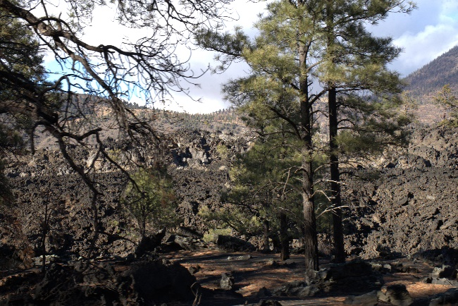
Although the mention of the Sunset Crater Volcano was not a predominant subject in my oral history interviews, the presence in the history of Wupatki and its significance by itself is very relevant: Indigenous’ oral tradition kept very present in their memory of the eruption of the volcano, and registered this event as sacred (Western et al. Association, 2021 p. 2 ) The Wupatki Pueblos, the Sunset Crater Volcano, and the San Francisco Peaks ( Dzil cho in Western Apache language) are deeply connected in Native American oral tradition. The Hopi believe that the Kachina spirits live in the volcano’s crater; they are mighty and perform ceremonial dances around it. Right when we were leaving Polotsom´s home, after a long journey around the Wupatki Pueblos, I could feel my body’s exhaustion as my heartbeat accelerated and my lungs and heart shivered. Also, I exploded in tears, but simultaneously, I felt gratitude.
Bonito Lava Flow, Sunset Crater National Monument.

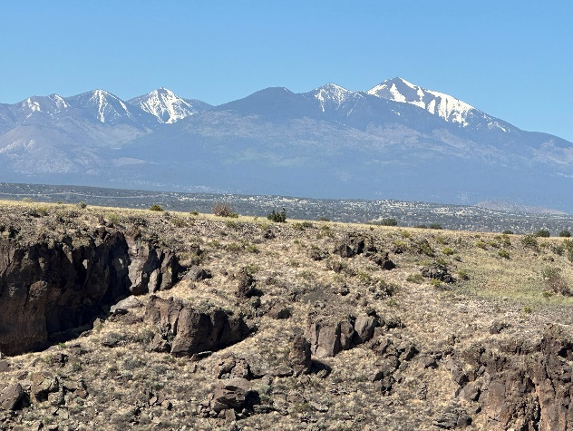
The San Francisco Peaks, or in Navajo-Diné: Dook’ o’ ostiid Ye´ii Bicheii, are considered the most sacred place for the Southwest Indigenous. As I mentioned, it is indelibly linked to the Sunset Crater Volcano in Indigenous’ cosmovision. The Zunis visit the San Francisco Peaks regularly to obtain spiritual power and ask for blessings, and their oral tradition also mentions the migrations to the Sunset Crater Volcano; its uniqueness is essential to them, as it provides spiritual energy.
The San Franciso Peaks or Dook’ o’ ostiid Ye´ii Bicheii

Wupatki, the Havasupai, and the Grand Canyon

One of the insights that has fascinated me most since the beginning of my research is that the Wupatki pueblos are connected to the Grand Canyon through centuries-old trails. There is evidence of Hopi trails between Wupatki and the Havasupai Grand Canyon area (Hartman & Wolf, 1977). The Havasupai land was right at the border with Wupatki Pueblos before the White men arrived in North America, so the interaction with the site is extremely likely.

The Havasupai oral tradition tells that their migrations went south “down to lands where parrots and monkeys lived” (Hirst, 2006, p. 41). Based on his research, Stephen Hirst stated that the Havasupai might have had contact with the Toltecs from Tula in Central Mexico and other cultures from the Central Valley. He also suggested that they might be the direct descendants of the Cohonina people, as they are also linked to the Desert Culture people, connected to the Anasazi (Hirst, 2006. p. 41); their language comes from the Uto-Aztec family, and it is believed their migration was over in 1300, they also used similar irrigations as the Aztecs (peoples from Mesoamerica). Moreover, the Hopi storytelling about their origins is that their ancestor emerged from the infra-world, deep down from the Grand Canyon (Waters, 1966, p. 78)

Who Built Wupatki? The People of the Southwest

Navajo-Diné scholar William E. Coffer explained in his book Sipapu: The Story of the Indians of Arizona and New Mexico that Native American cultures merged throughout the millennia and influenced each other with their cultural traits (Coffer, 1982). Something similar happened in Mesoamerica, where different cultures, such as the Olmec, Mayan, and Zapotecan, shared the calendar, human sacrifice practice, writing, and astronomy knowledge.
Coffer traces the Cochise culture as the oldest in what we know today as the American Southwest; the Cochise culture flourished 7,000 years ago, and there was found a point from the Clovis period, some 11,000 years ago. (Coffer, 1982)Afterward, the Mogollon culture emerged along with the Anasazi. The circular kivas, like the one in Wupatki Pueblo, were part of their architecture; this trait is not exclusive to the Anasazi people (Coffer, 1982, p. 5). Paquimé is located 250 miles from the border in Nogales, Arizona, and is regarded as the most important vestige of the Mogollon culture(Coffer, 1982).

The Ancestral Puebloan (Sinagua) and the Anasazi People

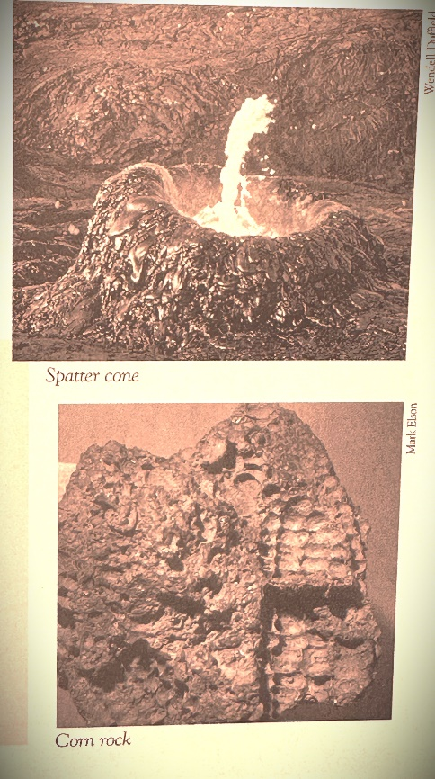
Archaeologist James C. Clarke named “Sinagua” or “those who farmed with no water to the people who lived in Wupatki before the eruption of the volcano. The Mogollon culture is directly connected to the Sinagua “the people from Wupatki” and their culture grew parallel to the volcano they ventured to go so close to the hornitos (spatter cones) formed after the eruption and left corn and create corn fossils over the lava (Fisher, 2015, p. 13).
Sinagua Corn Cob Fossils. Photo Credit : Wendell Duffield and Mark Elson, respectively.

However, Wupatki scholars’ consensus is that the Ancestral Puebloan culture disappeared with the mass migrations after the post-eruption soil became very fertile; the Ancestral Puebloan dissolved as a particular culture and it is in the Site Nuvakwewtaqa, in Arizona, where it can be seen where the Hopi ancestral culture merged with the Ancestral Puebloan tradition, for this site is linked to the last stage of the Sinagua culture. (Pilles, p. 11) How did the oral histories connect the Anasazi to their ancestors and the people who built Wupatki? It is worth observing that none of my narrators mentioned the word Sinagua. In all my oral histories with Native American narrators, they referred to the people who built Wupatki as “The ancestors,” the Ancient Ones,” or The Anasazi.

The Anasazi people inhabited our planet around 5000 B.C.; it is believed that they combined with the Hopi and the Zunis in southern Mexico and adopted traits of the Mogollon culture around 500 A.C. By the time the Sunset Crater Volcano exploded, the Anasazi were living in concentrated structures (Coffer, 1987).

We must notice that there is no mention of the Wupatki site in the Spanish chronicles documenting the Spaniards’ presence in the Hopi Mesas. Wupatki has always been a place of ceremonial activity (Stofflen & Van Vlack, 2022)

Hartman’s assessment of Wupatki mentioned that the Navajo-Diné lived there in the 1880s; a burial of six or seven children from this period was found in Room no. 7 at the main structure in the Wupatki Pueblo. There was a transit point to the Tuba City Trading Post, established in 1888 by Samuel Preston, where the Wukoki pueblo is located. The building of the railroad in 1882 sparked the war against the Navajo people and their territory.

In 1924, President Andrew Coolidge established the “Wupatki National Monument, which meant this would be a protected area and acknowledged as a cultural heritage of the United States. Later, President Roosevelt amplified and reduced the park’s territory (Hartman & Wolf, 1977).

To date, Wupatki is a place of worship, ceremonies, and pilgrimage for the Hopi and Zuni Nations, who walk on the trails connecting Wupatki and the Grand Canyon.

The Ancient People, their Migrations, and Contact with Mesoamerican Cultures

Migrations are very vivid in the oral tradition of First Nation peoples, and it is imperative to note that those migrations were not linear but circular (Chantaphonh & Ferguson, 2006 ); the Hopi storytelling states that it was the Bear Clan who took the lead in the migration to the south in the beginnings (Waters, 1977).

In the Hopi oral tradition, there exists a place called Palátkwatpi or “The Red House”; the Kachina spirits were the ones who built it; it is located down in Central Mexico. Frank Waters mentioned that Hopi spokespeople could read Mayan glyphs and stelae and connect them with Hopi glyphs (Waters, 1966, p. 68). The Hopi think it could be the ruins of Palenque in Chiapas, Mexico, and oral tradition claims that the clans stayed in the south: in Central Mexico, the Maya Lands, and Tula. (Waters, 1977, p. 71) “ Under the supervision of the Kachina people, Palátkwatpi was built in three sections surrounded by a high wall. The first section was reserved for ceremonial purposes, the second section, adjoining it, contained a storage room for food, and the third section comprised the living quarters for the people. (Waters, p. 71)

The ceremonial structure was the most important, and yes, indeed, it resembles the ceremonial centers founded in Mesoamerica. (Waters, 1977). It is crucial to consider that in ancient Mexico, oral traditions such as in the Mexica’s (the ruling empire that Hernan Cortes found upon his arrival in 1521) oral tradition, they acknowledge that their direct ancestors were the Aztecs, the people who came from Aztlan, a mythical place in the north. Hopi oral tradition tells that Hopi groups of tribes from the north founded Tula, an ancient city sixty miles north of Mexico City; eventually, they would migrate southeast down to Chichen-Itzá, in the heartland of the Yucatan. Then, the Hopi clans divided again; some lived the “easy life” next to the waters, and others went back north (Waters, 1977, p. 70).

Hopi narrators revealed that those people were considered “aberrant Hopis” who chose an easy life. “So Palátkwatpi grew and prospered; no crops were unattended. (Waters, 1977, p 70) Furthermore, Chip Colwell-Chantaphonh commented on that particular matter that Palátkwatpi were fertile lands in the south that destroyed the Hopi way of living, there were floods, and they walked northward and settled in the Hopi Mesas in Arizona (Colwell-Chantaphonh, 2006).

Chapter Two: Learning about Indigenous Ways of Knowledge

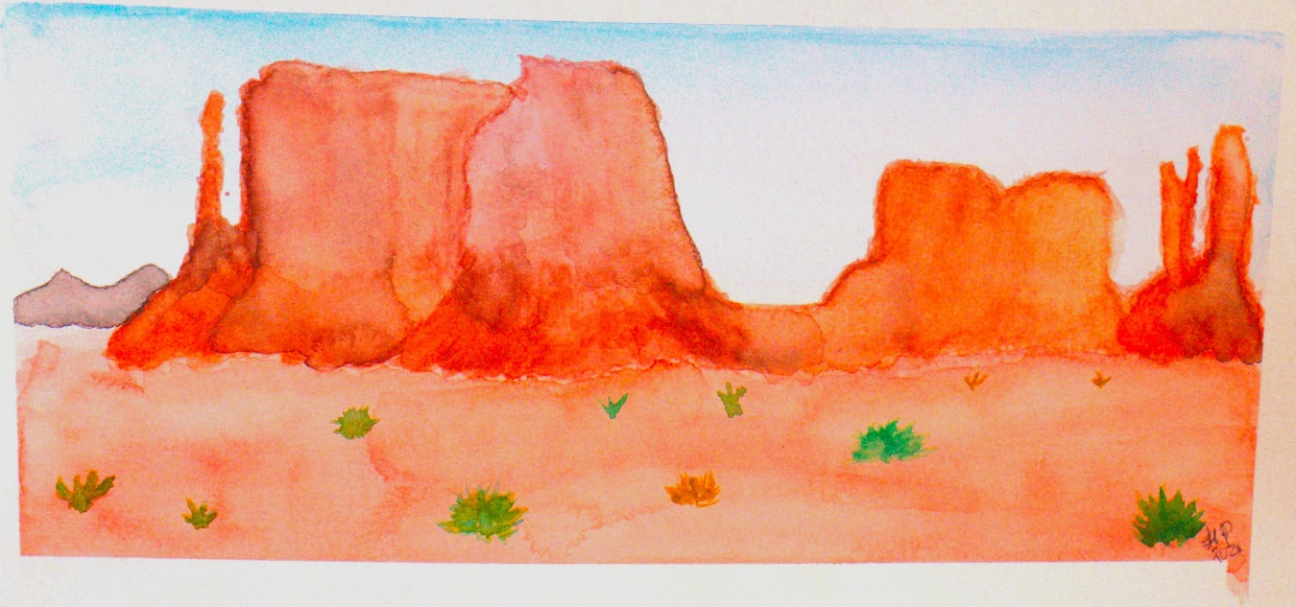
Monument Valley, Arizona. Navajo-Diné Homeland

It is essential to present the indigenous scholars who influenced me the most along this journey of knowledge. Their ideas shaped the perspective I should bring into my scholarly formation, how I should approach my interviewing techniques, and my comprehension of my Native American narrators’ storytelling.

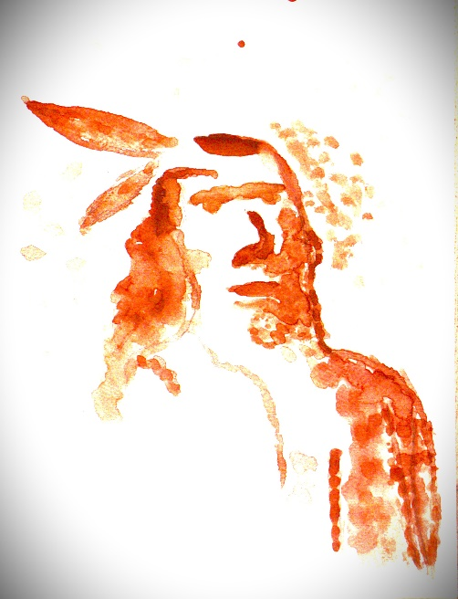
Alvaro Enrigue noted that Native American narratives have their own rhythm and their own movement: “Native American storytelling does not fit in historiography” (Enrigue, 2005, p. 98).

I learned two core concepts as part of the OHMA curriculum: indigenization and decolonization. Although these terms deserve to be discussed in depth and a lot more thoroughly, I would limit myself to introducing them with brief definitions. Indigenization constitutes an axial methodology that implies naturalizing Indigenous knowledge systems in our research approach and making them evident to transform spaces, places, minds, and hearts (Waziyatawin, 2005). Decolonization is the concept that all my research and work during the OHMA program spun around. Decolonizing practices aim to deconstruct colonial ideologies of superiority and privilege of the Western epistemologies (Waziyatawin, 2005). Decolonization demands more negotiation with collective memory (Mahuika, 2019). The process must address unbalanced powers and dismantle structures perpetuating the status quo. Both processes require shifting of frames of our own knowledge.

As a Mexican woman, I also had to undergo an intense process of decolonization and reassessment of my visions, also as an oral historian, as a scholar, and even as a human rights activist; I reflected on this after reading Gayatri Spivak’s concept of Otherness: as colonized researchers we accept as dogmas Western frameworks of epistemology (almost as dogmas, we do not question them), and that pulls us apart from our own cultural traditions, beliefs and references, thinking of them as “inferior”(Chilisa, 2020, p.6-7). Chilisa pointed out the need (and perhaps obligation) to reconsider, reframe, and re-elaborate our systems of knowledge, merging them with indigenous epistemology, ontology, hermeneutics and axiology and incorporated in our qualitative research, analysis and theory making; this is what she called The Transformative Paradigm (Chilisa, 2020) Pretty early on, I was conscious of the need of start breaking apart my own axiological background as well.

In the earliest stage of my oral history project, I encountered a significant research paradigm: the dissimilar nature of the Western epistemology and Indigenous people’s; therefore, I would have first to understand separately, and thus combine both approaches and prioritize, of course, for the Indigenous scholars’ proposals. Timothy Church and Marcia Katigbak defined this moment within the indigenization process as the encounter stage (as cited in Chilisa, 2020), which occurs when the researcher realizes Western methodologies, categories, and theories would not suffice to address and explain specific issues; they also defined the concept “ immersion- emersion stage” as the time when researchers must put aside Western research paradigms in favor of Indigenous ones (Chilisa, 2020). For instance, Hopi purposes of historical storytelling are very different from the Western as the Hopis embody history and myth in a lived totality (Loftin, 1994, 680); the Melanesians also embody myth long before they articulate the verb (Loftin, 1994, p. 682); as opposed to the Western purpose of history which is obsessed with the “what happened actually and the “hard data”.

Oral Tradition and Oral History

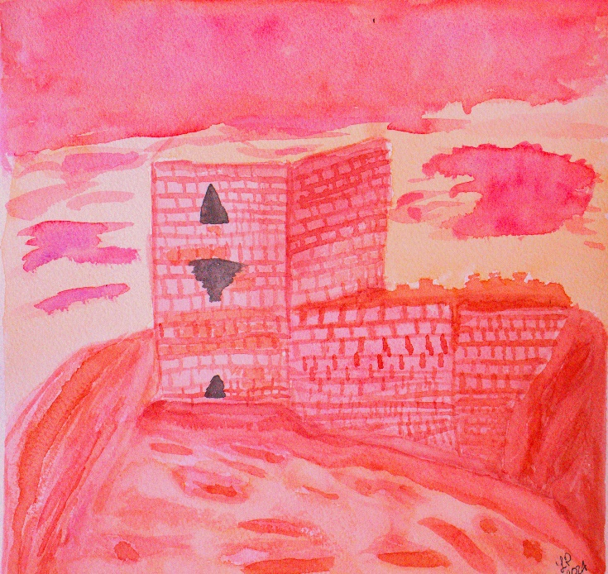
Nēpia Mahuika’s scholarship was pivotal in my learning about the vital role oral tradition plays in decolonizing and indigenizing epistemological processes and that oral tradition and oral history are two engines that work together, feeding each other , however, not all the time those engines are synchronized. He remarked that oral tradition is not part of an abstract time based on myths but is part of Indigenous history. Western academia has to reconsider its social and humanistic approach to how Indigenous people understand the world, especially in these times of arrest with global warming (Mahuika, 2019). It is essential to mention that Mahuika acknowledged the seminal work of Jan Vansina, Oral Tradition as History, published in 1985, on oral tradition. Vansina’s core premise is that oral tradition narrative can be considered part of the historical narrative.
Wukoki Pueblo in My Mind.

In the earliest stage of my oral history project, I encountered a significant research paradigm: the dissimilar nature of the Western epistemology and Indigenous people’s; therefore, I would have first to understand separately, and thus combine both approaches and prioritize, of course, for the Indigenous scholars’ proposals. Timothy Church and Marcia Katigbak defined this moment within the indigenization process as the encounter stage (as cited in Chilisa, 2020), which occurs when the researcher realizes Western methodologies, categories, and theories would not suffice to address and explain specific issues; they also defined the concept “ immersion- emersion stage” as the time when researchers must put aside Western research paradigms in favor of Indigenous ones (Chilisa, 2020).
For instance, Hopi purposes of historical storytelling is very different from the Western as the Hopis embody history and myth in a lived totality (Loftin, 1994, 680); the Melanesian also embody myth long before they articulate the verb (Loftin, 1994, p. 682) ; as opposed to Western purpose of history which is obsessed with the “what happened actually and the “hard data”. Tesse Naranjo accurately observed that Native American oral tradition is more axiomatic than hypothetical

Mahuika observed that oral tradition is the means to decolonize Western societies.: “Indigenous oral traditions must not be any more as the periphery vision; we must question all the visions imposed by the white settlers” (Mahuika, 2019: 37). We have to incorporate Indigenous ontological references and the view of Indigenous storytelling into our scholarship and research apparatus. Indigenous storytelling is crucial to understanding where we come from and where we are heading. As Mahuika wisely stated, “Indigenous perspective needs to be a lot more influential in the oral history scholarship, not only Indigenous scholars but the whole community” (Mahuika, 2019, p. 38).

Through Roger Anyon’s words, I began considering the relationship between archaeology, oral history, and oral tradition. He wisely taught me that oral tradition can enrich archaeology and augment an existing oral narrative, the narratives of the ancestors, which have multiple levels of meanings; they connect different times and express collective remembrance of generations (Anyon, 1997).

In the next chapter, along with my narrator’s oral histories, I will continue this conversation about the interconnection between oral history and oral tradition.

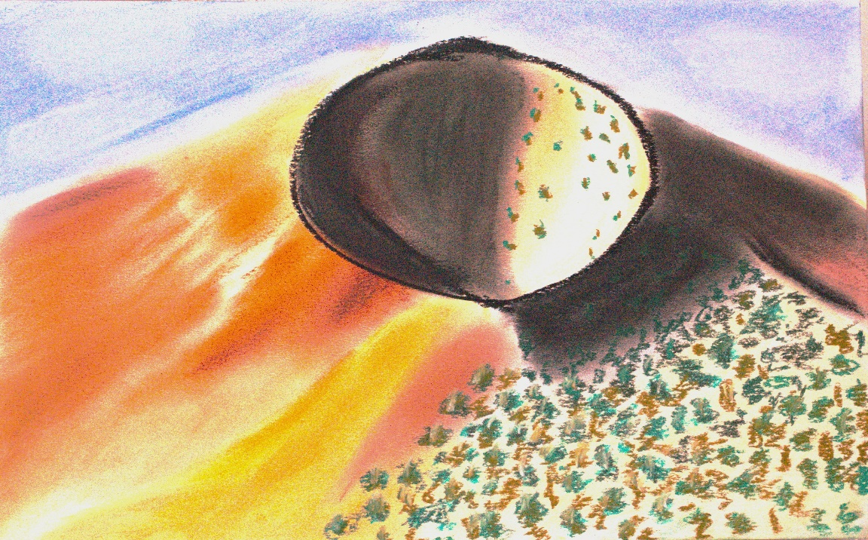
The Eye of Wupatki

Bagele Chilisa and Third Space Methodologies

Botswanan scholar Bagele Chilisa proposed the term Third Space Methodologies, which she defined as those spaces that challenge and contest Western methodologies, and those spaces involve a cultural-integrative research framework where Indigenous perspectives and methodologies are in command. They are more palpable and dominant.” (Chilisa, 2020, p. 32)

The Third Space Methodologies theory is one of the theoretical frameworks of this Oral History project; this concept establishes that the vision and perspective of the Indigenous people would lead and most prevail in the research analysis and paradigms(Chilisa, 2020). Indigenous storytelling and narratives must take over the social science scholarship as they counterpose the imposed memories and historical narrative of white supremacy: the history of our country does not start with the arrival of the Europeans on the East Coast. The oldest and most universal human quest is, who are we? Indigenous oral traditions provide more satisfying answers, relying on ancient storytelling, oral tradition, our ancestors’ tales, and the power of imaginative transformation that permeates Indigenous cosmovision (Chilisa, 2020). Third Space Methodologies would lead us to understand our role on Earth and in the Universe and face the future under that understanding and premises, as Mahuika said, especially in this time of global warming.

Polyphony of Voices and Multivocality

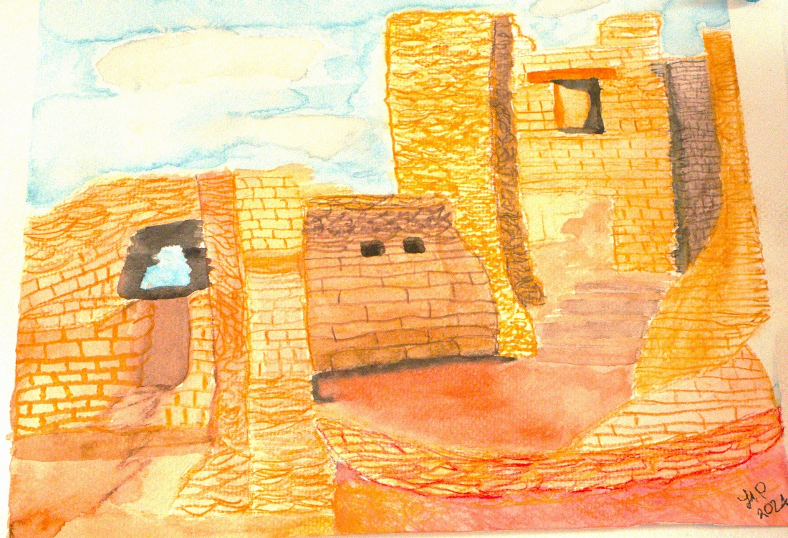

After reflecting on my methodological essay about how a polyphony of voices represents the most appropriate vehicle to include many points of view, perspectives, and, of course, a variety of multilayered narratives, Chip Colwell-Chanthaponh introduced me to the term “multivocality,” a precept conceived by Margaret Rodman that embraces the conjunction of voices and narratives (Colwell-Chanthaponh, 2006). Multivocality is the key to understanding and co-creating a narrative of the particular and unique way the landscape expresses itself. Multivocality is the tool to shape the polysemic meaning of places for different users (Rodman, 1992). Multi-vocality allows archaeology to go beyond its colonial legacy. Chanthaponh wisely added that multi-vocality will not resolve all the iterations from the soul-contested past. Still, it could provide some resolution, such as intelligent and connected political decisions connected with spiritual beliefs(Colwell-Chanthaponh, 2006). The Wupatki Pueblos were the mnemonic force I chose to structure Indigenous storytelling around subjects like a sense of place, memory, identity, and Indigenous ontological frameworks. In his discussion about memoryscapes, Toby Butler pointed out that it is elemental to bring together a range of voices and memories that will turn into a multilayer experience and impression of the place. (Butler, 2007)

Finally, Nēpia Mahuika observed that life narrative offers a personal account of traditions( Mahuika, 2019). The narrative and storytelling in my interviews with Indigenous narrators ooze oral tradition; their life narratives are constructed with knowledge and memories passed down orally, not through written books. Rather than a practice of oral history, my interviews with my narrators were a practice of oral tradition, where history, archaeology, myth, identity, and sense of place amalgamated in their storytelling and narrative construction. I will expand more on this matter in the next chapter.

Chapter Three: The Indigenous Sense of Place

“Sense of Place is the Remaining Terrae Incognitae”
-J.K. Wright, Terrae Incognitae, 1947.

“ Places recall stories, and stories recall places”(Colwell-Chantaphonh, 2006, p. 151). My interviews with Native American narrators were incredibly rich in this aspect. The subject is so complex, profound, and relevant for the decolonization and indigenization practices of oral history and historical narratives that it is worth expanding on in a doctoral dissertation. Since this is not the case, I am presenting the most relevant aspects to discuss the making sense of place about the Wupatki pueblos and its surroundings within my Indigenous’ narrators, with whom I am deeply thankful.

Places and spaces are axial in the human life experience. Places are repositories of memories, individuals, collectives, ancestral, and those from immemorial times. Western narrative theory is only possible by locating it within time and space(Colwell-Chantaphonh, 2006). As literature has demonstrated, Indigenous storytelling challenges the linearity of time; some scholars even suggest that the nature of Indigenous storytelling is atemporal. However, place and space are primary to the foundations of narrative and in the construction of storytelling. “Places become inseparable of traditional narratives” (Colwell-Chantaphonh, 2006, p. 151). Valipoor noted, “ The overall understanding of the definition of sense of place shows that the sense of place results from both human interrelations, their mental imagery and environmental features (Valipoor, 2016, p. 213).

The emotional and affective relations (and reactions) humans have with places are irrefutable; Yi Fu Tuan´s work is referential as he discussed the meaning of topophilia, which, in few words, refers to the affective bond between people and place and is a fundamental aspect of human experience( as commented in Butler, p. 366). Tuan expressed that “ topophilia is diffuse as a concept but vivid and concrete as a personal experience” (Adams, 2018, p.227). The construction of the landscape is a dual experience; it's both natural, physical, and embodied; it is mental, intellectual, and historical, and it embraces a variety of meanings. (Feld, 1996). I agree with Stephen Feld’s argument that the construction and perception of the landscape are overwhelmingly visual and need to be more oral and aural. (Feld, 1996). It is essential to focus on the environment's role as an actor in shaping our ontological constructions of the world (High, 2016), phenomenology and space are indelible elements, the place determines our psyche and the mechanism we develop to understand, react and interact with everything that enters our sphere, our space, especially in our minds, if we conceive the mind as a place-space that holds all that conforms our identity and idea of self-existence. Even animals experience sense of place with their physical senses and instinct.

“I loved the Wupatki National Monument because of the history that it provides and how the place is able to tell me that our ancestors lived in that area. We went to visit one of the National Parks in Utah, in Arches around Moab. When we went there, I was like, “Oh, it's so beautiful,” and my sister and I just went for a walk up to a snowball, and we're just like, “It's so beautiful, it's so peaceful; I just love being outside.”. And when we went to visit Arches, I was like, “Oh, I get such a great feeling; it feels so good; it's so peaceful.” My thought was something good. It must have happened here because it makes me so happy; it makes me feel good, and I think other people feel that, too. It makes them happy, and it makes them feel good; something good must have happened in these places. So, I think that's what brings people; it's just a good feeling. I'm so happy that National Parks are available for us to go and visit because a lot of good has happened there, too, and probably not only that, but these places have God's hand in its creation, and the trees and the dirt, the smell of the dirt, I love it. It makes me think that instead of us being so centered, we get stuck in our buildings and enclosed brick walls, and we get so busy. When you get out and you visit those places, it brings harmony and balance back to your life. That, and I think that's what's attracting us to those places as well. Because when we get overwhelmed and stressed, we can go to those places, and it makes us relaxed again. (Dayana Sagoni, Resident of Doney Mountain, Navajo-Diné Nation, interviewed by Florencia Ruiz Mendoza, 30/05/2023)
Sagoni 1.mp3

Nēpia Mahuika in reference to archaeological sites and objects he observed that the Māori people relate to them as if they were storytellers, pit houses, carving, petroglyphs, etc. were alive; they speak about the past they tell stories about the place, objects are living memories, they are memorial entities that carry the life.. The Māori connection with the landscape is crucial; it goes beyond physical attachment. Furthermore, physical space is essential to constructing a narrative. (Mahuika, 2019)

Wisdom Sits in Place

“If you know the history, if you know your culture, if you were raised in it, even, and that's to varying degrees, but even if you have just a basic understanding of who you are and how your people came to be, that does allow you to look at the landscape differently. I know for a fact that my ancestors have been around here for thousands of years, and I'm just fortunate through archaeology to have more information about the general, every specific geographic region. Still, I do get the sense that there are deep spiritual connections, that are hard to quantify. I can't fill out a data form that tells you how spiritual I am. It is only something that we as individuals and groups of community members can express and feel in our own ways in that landscape. Maybe as a Hopi man, I'm taught a certain way how to interact and introduce myself to the landscape, to a site, to a rock art panel. (Balenquah, Lyle. Archaeologist, Hopi Nation. Interviewed by Florencia Ruiz Mendoza, 20/12/2023)

Balenquah 2.mp3

Keith Basso’s article “Wisdom Sits in Place” became the steering wheel of my theoretical approach to my oral history project, Voices from Wupatki, as it was my first approach to the term sense of place. His work is pivotal and an essential reference for those interested in Indigenous ways of Knowledge and the sense of place. Every Indigenous and non-Indigenous scholar who explored the subject of sense of place and non-Western research methodologies quoted and referred to Basso's work. Basso lived among the Western Apache Nation, the Cibicue, and in his text, he discussed a fundamental topic: how the Apaches make sense of place and conceive the mind as a place itself; moreover, he discussed wisely the connection between places and knowledge generation. His groundbreaking work thoroughly explained the complexity and particularities of the Cibicue Apache connecting to the landscape, adding that humans are part of that landscape, and we are often active agents in the transformation of the landscape. And indeed, Lyle Balenquah´s narrative exemplifies this precept clearly and compellingly.

Colwell-Chantaphonh wisely noted that we must understand that recognition of real places does not take away its symbolic interpretation. He remarked that Zuni oral history understands migration and its trails as real and symbolic simultaneously; the actual trail or road is not the same physically speaking, but the meaning and the symbolisms remain in their history and cosmovision.” (Colwell- Chantaphonh, 2006) Hopis think that place expresses a range of emotional experiences, all grounded in the notion that the ruins are not inanimate but living through the continuing presence of their spirits (Loftin, 1996).

The Yebochese
“ For some reason, they don't have any history on it. There's some, but it's hard to read. The drawings are hard to read. I've seen some, there's, I don't know if you've seen it, they call it “Yebochese”, but there's alien beams on top of them. I don't know what they are, but there's alien beams on top of them. in a native culture, they call them “Yebochese”. And I really don't know what they are, but “Yebochese” is like a native culture thing. And I don't know what's on top of them. Like unnatural forces, I guess you could say, because it's almost like pyramids. When you look them up, the pyramids, they're unwritten and they're unspoken. You don't know what the riddle means. It's just like that. It's just like a hieroglyphic. And I know where they're at. I've never seen one like that.” (Wanwinkle, Mike. Resident of Flagstaff, Hopi Nation. Interviewed by Florencia Ruiz-Mendoza, 21/12/2024)

Ancestral Memory Sits in (Sense of)Place

Basso defined the concept of living topographies as sites of awareness, this notion resonated deeply in me, as a consequence of being a historian and advocate for memory and human rights, I am very familiar with the concept of “site of memory or “site of conscience,” which in a few words, this is about how places made of aware of something; a site of conscience create awareness and connects past to present. Places generate knowledge, but this is not an isolated process, either from the Indigenous point of view or the West; humans construct places according to our system of beliefs and social conditions. The Western axiological notion of history is focused on proving the actual events, as opposed to the Non-western idea of history, which is about getting in touch with the ancestors to look for answers in the past, in the community’s memory:

“There are little structures all the way through the valley. Wupatki was in the late 1100s. I never was around the 1100s, but they say it was. It has a lot of history to do with this area and how it turned out. But, if you go past the Wupatki area, I guess it is the gateway to the Grand Canyon. And the Havasupai probably have more information on Wupatki and why it was built. If you think about it, I think they navigated to the canyon and still survived through the canyon to the Havasupai Indians. They built structures just like they have in the Wupatki area; some probably navigated that way, and some navigated to Hopi. But who knows? Because their structure is one of a kind. (Wanwinkle, Mike. Resident of Flagstaff, Hopi Nation. Interviewed by Florencia Ruiz-Mendoza, 21/12/2024)

Keith Basso and Margert Rotman discussed the term: “empowering the place.” Basso defines it as the capacity to trigger and retrieve consciousness, awareness, ideas, and identity (Basso, 1996). Rotman situates this idea in the social construction of places; space is constructed upon our experience. “Space is socially constructed and contested in practice” (Rotman, 1992). I agree with this idea; spaces, their narratives, and their meaning are as contested as history. The indigenous notion of history is multilayered: “memories are piled upon memories with a visible mark on the landscape that showed that people loved there” (Rotman, 651). Bagele Chilisa observed that the Western notion of history is very much centered on individual conclusions, as opposed to community knowledge; oral tradition contains the memories and experiences of generations, and it is passed down orally in songs, poetry, storytelling, dances, etc. (Chilisa, 2020, p. 92). History might be spatial and temporal, but memory is not. Dayana’s words illustrate this powerfully:

“I visited Wupakti probably, I would say, five times, but I just love the fact that these people were just as knowledgeable as we are. They took time to look at the stars, and they took time to work hard; it takes a community effort to work together to be united, and I know that these people had knowledge of making mud, clay, and cement so that they could build their homes and give them a place of feeling grounded, and so. And in order to survive you have to work unitedly as a community, as a family so that you can break the ground, you have to have knowledge of good soil, and they had knowledge of that; knowing when to plant and what kind of seeds work, and they had an understanding of the seasons and the climates and the weather. And to look back and to know there's history, I like that.” (Dayana Sagoni, Resident of Doney Mountain, Navajo-Diné Nation, interviewed by Florencia Ruiz Mendoza, 30/05/2023)

Sagoni 5.mp3

Nēpia Mahuika extensively discussed the similarities and differences between oral history and oral tradition and emphasized that collective memory and community knowledge are an essential element in oral tradition. In contrast, oral history could rely entirely upon a complete personal ontology and life narrative. In Indigenous storytelling, personal narrative is deeply intertwined with collective narrative and memory:

“From the Hopi perspective, Wupatki is considered to be an ancestral homeland for numerous Hopi clans. My clan included. Both of my clans were matrilineal people, so I identify with the Greasewood or Tawengwa clan from Third Mesa. That's my mother's side. And my father's side is Rattlesnake clan or Tsu'wungwa from the village of Bacavi as well. Both of my parental clans have ancestral ties to Wupatki. And so from the Hopi perspective, we view Wupatki and the whole region there as ancestral homelands to many different clans that resided there for not just, the popular archaeological stop that you see there, the structures, but also way back in time. So we have evidence that Pueblo people, folks from the Clovis and Folsom cultures, were inhabiting that landscape. And so we identify those folks as part of our ancestral lineage.” (Balenquah, Lyle. Archaeologist, Hopi Nation. Interviewed by Florencia Ruiz Mendoza, 20/12/2023)

Balenquah 6.mp3

“They have… they had a little bit different culture than us. They've been here before us. And the Hopi people were here before us, too. I think they were… they lived with each other back then. And Grand Canyon, too. They said that they came from the Canyon. And they used their, their rocks to build their, their houses. They live in the rocks. And they, they were, they just grew crops. They lived by the water mainly.” ( Teamster Clarence Interviewed by Florencia Ruiz Mendoza, 20/12/2023

Teamster 7.mp3

Spirituality and Cosmovision Sits in (Sense of) Place

“A Place is loved for its powers of restoration, validation, and transformation” (Adams, 2018. p. 227)

“It is the First Sacred Mountains, and one of the First Sacred Mountains is (the) Flagstaff Peaks, and that's probably what the Wupatki Nation believed in, too. I mean, it should be because if my native language has that ability to believe this mountain right here, San Francisco Peak(s) that we see every day, if that's a sacred peak, I'm sure Wupatki has something to do with it too. You know what I mean? Because I have it on my chest right here. I guess it means something, right? (Wanwinkle, Mike. Resident of Flagstaff, Hopi Nation. Interviewed by Florencia Ruiz-Mendoza, 21/12/2023)

.
A Zuni tribal member expressed that archaeological places and vestiges have not been abandoned as they still have the same spiritual ties to those places as their ancestors did. ” (Colwell-Chantaphonh, 2006). This oral history’s excerpts reflect what Bagel Chilisa noted: respect for the landscape and the environment is essential in Indigenous research methodologies: “Knowledge is held in connection with the land.” They combine also an indelible component of spirituality and connection with the geography of the land and the local features of it, as well as the position of the stars in the firmament. The following excerpts show the connection between the sacred, the San Francisco Peaks, and other landmarks around Wupatki and the Sunset Crater Volcano.

“In Diné culture, there's this big thing about death and anything related to death. They don't belong here. So there are things that people say and do today that are very contrary to that. So the way I stay connected to my culture is there are various teachings that were given to us. You could throw them all away. You could take some of them or you could take all of it. For example, we have basically six sites in the land that are observed we should know about. We should visit. We should understand the stories behind those six. (There's some left. But four are the cardinal that deal with the colors. The four cardinal directions are the mountains. And one of them is right here. And this is unique because this peak is the embodiment of Navajo's, all Navajo peoples, of what the person that we call sun (inaudible word) or the mother of all of us. (Manygoats, Glen. Resident of Flagstaff, Navajo-Diné Nation. Interviewed by Florencia Ruiz-Mendoza, 21/12/2023)

Manygoats 9.mp3

“She's here. And so one of the things I do when I go to the slopes, any time I go, I don't go often, is I talk to them, talk to them. From the Western world, as they look at it, I talk to the peaks. But when I go from my side, I talk to my mother. Go visit her, talk to her for a while, and I come back there's another one in Colorado. The other one's in New Mexico. And so between these four peaks, when I'm between them, I'm in Navajo land. That's where everything lies, everything is within. So that's how you love this, what we call Mother Earth. But she's the embodiment out here sitting at peaks. So that's how I'm attached to it. I go down to the very core, the very basic beliefs and just leave it there. There are the basic beliefs and there's other things that are built on top of it. All this, I just like, once you get into that, it complicates everything. It's tough to live a life like that. Not today, not today. And when a chunk of it's gone forever, it's, you know, that's tough.” Manygoats, Glen. Resident of Flagstaff, Navajo-Diné Nation. Interviewed by Florencia Ruiz-Mendoza, 21/12/2023)

Manygoats 10.mp3

The Alignment with Stars

“We go by the stars. The alignment that we came by, by the stars at night. The alignment to where, which way is north, east, south, west. And they came here before us, and we came after them. They weren't living here then because the Europeans, the outside people, came here between those times. From Mexico and on to here in Arizona, just by the historical, it's all, they have a line with the latitude and longitude. They did not have any back then. And latitude and longitude. They had a line of it before, but that is what I think. I mean, I have just seen it though... there… the historians, they, they talk about it with, from Mexico City or mines. It aligns with the Hopi people, the Pueblos. And Chaco Canyon. Everything is aligned with the stars. I've seen it a couple of times, though; I try to figure it out sometimes, you know. But I changed my religion though”. (Clarence Teamster, Kayenta Resident, Navajo-Diné Nation. Interviewed by Florencia Ruiz Mendoza, 20/12/2023).

Teamster 11.mp3

Identity Sits in (Sense of) Place: How Wupatki Resonates Differently to Hopi Navajo-Diné, and Zuni Nations

Places play a determinant role in our identity, and our identity is key in how we relate to the location, with the landscape, and how humans decode and interpret them. The most important condition of identity is to be identified. In fact, the term reidentification does not mean only identifying things but also experiencing meanings and concepts (Valipoor, 2016).

Anthropologists claim that making sense of place represents the social construction of the place. Nepia Mahuika stated that the spoken word is embedded in the context and a situation in a setting. The landscape is a vibrant space that reveals millenary stories. Places are multilocal and multiple for each habitant. A place has a unique reality and meaning and is shared with other people through narrative. (Rodman,1992, p. 643). Paul C. Adams asserted that “place attachment is a performative process insofar as one projects oneself out in place to perform one’s attachment, and speaking about the place is yet another performance that validates parts of the oneself” (Adams, 2018. p. 234).

Margaret Rodman was talking about when she referred to multilocality as the interaction of different places, and she added that space is socially constructed and contested in practice. For other Native American nations, Wupatki National Monument and its surrounding environment have diverse meanings within their cosmovision and praxis. (Rodman, 1992) Keith Basso explains that in what anthropologists call the social construction of the place, there are other elements implied in that process, like the particular social fabric of the individual (Basso, 1996), but also what Maurice Halbwachs conceptualized as collective memory and ancestral memories as stated before. The following oral history excerpts reflect clearly that the sense of place responds primarily to our identity.

“And then we all moved down there and then, a few people stayed up there, I guess. But there’s nothing it's a ruin now. Anyway, when they got there, they walked up to where Wupatki is now, and they built that settlement. And the thing is Wupatki --when you went to the visitor center-- that's not Wupatki, that's Wuko-kihö, Big House. Wupatki is down towards the river; it's just a tiny little thing, see? So, a lot of people don't know that, but we stayed there for a long time. That belongs to the Snake and the Sand clan because we built that a long time ago, and then we moved on, going back to different directions on our migrations, so that's our story of Wupatki. And sometimes, when the end of the snake dance, I'm sure you've heard about that at Hopi, the snake priests will take their offerings and they go to Kowestimai (The North House) where this all began and they take it to where this little plaza area is and there's a shrine there where they leave the offerings.” (Loren Kootswatewa, Educator, Hopi Nation).

Kootswatewa 12.mp3

A sense of place is a combination of meanings, symbols, and qualities that people perceive from a specific location. Places create different senses among different people, and old experiences within the individual are effective in creating a sense of place and belonging (Valipoor, 2016).

“The very first time I went there, I was young. I was probably, like, maybe 10. Then I went back later in life, probably in my mid-20s, and the thing I noticed was the way they built their homes was out of stone. Navajos don't build their homes like that. We build ours called hogans, and in our culture it was the animals that taught us how to build it, and in this case, it was the beaver that taught Navajos how to build their homes. They use wood. There are two different types. There's a male and female hogan, and when we went to Wupatki, I remember thinking “wow, this is not how Navajos built their homes”, and so this was like a totally different tribe to us, I already knew, from that when I saw their homes. I'm like “this is not Navajo”, this is someone totally different” and I saw one of their arenas where they played their game. We went through their houses and their doorways were very small. Navajo doors were pretty small too, but they're not as small as that, that was really small. I was thinking “wow, they must have really had to, because I'm a pretty tall guy”. I'm 6'1", and Navajos are pretty tall, so I was just kind of amazed by that, really, more than anything. Then, of course. I can't remember the tribe's name, I know the place, Wupatki. I don't even know if that's the tribe, the name of the tribe, or what are they called?, Mogollon, or whatever they may be, but that was a long time ago since I've been there. (Bighorse, Erickson Psychologist, Navajo-Diné Nation. Interviewed by Florencia Ruiz-Mendoza 20/12/2023)

Bighorse 13 .mp3

“I don't remember the first time I visited Wupatki because I think I went there as a child. But I do recall one of the times that I went as an adult because that's the first time that I took my own children. And I thought it was important to be able to take them to a place and explain some of the regional history, but then also some of the reason why it's important that we as present-day Hopi and Diné people acknowledge, kind of, the footprints of the people who came before us. As a Hopi person, my lineage, we don't track back in our clan history through Wupatki, primarily from the north up in Colorado and then from the south. So, a place called Homolovi. I think it's important to acknowledge that those histories are still being told. So, there are people who are present-day Hopi people who can trace their lineage and their ancestry through the people who, you know, made their stay at Wupatki. It was also a major place of trade, so a lot of people gathered there over the years and met there for very important reasons, regarding the things that they're trading from the west, further from the south. (Honani, Samantha, Educator, Hopi-Diné Nation Interviewed by Florencia Ruiz-Mendoza 22/12/2023)

Honanie 14.mp3

“For Navajo, those types of ruins, we call them, they belong to the ancient people, okay? Those are people that came before us. And so, we, as Navajo, we don't really go to these places. They're kind of, they're kind of pushed off because it doesn't belong to us. So naturally, the broad categorization of those people, we call them, Anasazi. Anasazi is kind of like, especially to young people, they're kind of like forbidden. They're kind of like forbidden to interact with that ancient culture, which usually means we don't bother their stuff, we don't visit their ruins, we don't go through them, we don't pick things up, we don't touch what's there. We see it, but we naturally kind of avoid it. So that's why, that's just our relationship to these ancient Puebloans, different cultures, which includes Hopi and all the other ones in New Mexico and all of it. We just avoid it. That's how Navajo, the traditional Navajo view it. We just not, we don't interact with it at all” (Manygoats, Glen. Resident of Flagstaff, Navajo-Diné) Interviewed by Florencia Ruiz-Mendoza 21/12/2023.

Manygoats 15.mp3

Migrations and Erased Borders: Where Indigenous Oral Tradition and Myth Meet with History.

“The Hopi is made up of a clan system, and it's vast, so all I can say for myself is that I'm a member of the Snake and the Sand Clan, and we have our own places where we've been on our migrations. And when we went south to what they call the Edge of the Water… that was our instructions. So we went south all the way to Baja (California) then came back; and went down the West Coast of South America all the way down to the end, the Antarctic Ocean. That's the Edge of the Water, the shore. Then, from there, we turned to the left, and then we went up the East Coast.” (Kootswatewa, Loren. Educator and Handcrafter. Hopi Nation, Interviewed by Florencia Ruiz-Mendoza 31/5/2023)

Kootswatewa 16.mp3

In her research about ancestral stones in the village of Wamira in Papua, New Guinea, Miriam Kahn explored the concept called: “spatial anchoring of myth.” I understood this term as the possibility of situating or locating the myth in an actual place on Earth. This is where myth, oral tradition, and history meet. (Kahn, 1990)Kahn helped me to understand how mythological events are embodied and how indigenous epistemological and ontological references lie on land and physical spaces. She observed that people understand their past and record it about a spatial experience comprised of tangible geographical features, such as healing mountains or alterations in the landscape made by humans, such as archaeological buildings, petroglyphs, and other imprints of human transformation over space. (Kahn, 1990)

These migrations took hundreds of years to complete and then we came up and eventually, we came to Central America now. We ran into our other people, the Mayans, Aztecs, and Incas on the cross. We all kind of melted together because we already were the same people, because we speak the same tongue, Uto-Aztecan dialect, Mayans, Aztecs, Inca, so that's where we come together. And, -do you know about the Mayans?, they study the stars, the calendar, way back… and when that happens we do the same thing here. This was done continually and every so many times, every so many suns or moons, then this man would announce to the village chief it's time that we do this week. It's a ceremonial calendar. We just did that and that's how we told time a long time ago and so that was our connection also to the Mayans because we came from the same place, and then as we went up to Mexico City which was just a big volcano and we knew all these peoples that were there. (Kootswatewa, Loren. Educator and Handcrafter. Hopi Nation, Interviewed by Florencia Ruiz-Mendoza 31/5/2023)

Kootswatewa 17.mp3

Miriam Khan also detected that whereas the Western world's focuses on temporal relationships between events in order to construct the historical narrative, Melanesians appear to focus on spatial relationships, my narrators' storytelling reflects the same phenomenon, as we already appreciated in the oral histories excerpts which addressed several times the inherent connection between Wupatki, the Sunset Crater Volcano and the San Francisco Peaks; furthermore, I observed in my narrators’ narrative the continuous mention of physical spaces and its relationship between them; those places are seen as linked points amid the physical space and its tangibility that would connect the past to present and provide a sense of history continuity and identity. (Khan, 1990, p. 52)

Furthermore, Khan perceives place as a historical record and a confirmation of fact. Her reflections on her work made me realize that Indigenous communities rely on oral tradition to convey their accounts of migration from central Mexico through Central America and further south, connecting these narratives to physical landmarks such as the pyramids of Mexico and Chichen-Itza in the Yucatan.

I was invited to go outside of Hopi in 2007 to Peru, and when I was there, I began to see the symbols and the stories of how it's very similar to our teachings, our philosophy, and the two deities called Pöqánghoya and Palöngawhoya, the two twin warrior gods, they have them down there also too, and I was like wow this is very similar; then I remembered one of my uncle's teachings. He said when our ancestors migrated, they also went down through Central and South America, some of them stayed and became who they are, and some of them came back and brought some of their teachings also, so the biggest thing that we have, the connection that we use in ceremony is the kiajo, the parrots, the parrot tails, the parrot feathers, that's what we took from there, and now we use that in our ceremonies, so we don't have parrots here, but it came from South America, Central America, and the place in Chihuahua, Mexico, a place called Paquimé. That's where they had this huge parrot trading place, and that's where they also raise the parrots, and then they trade it to Chaco Canyon, and from there it spread, you know, so I was like this is very beautiful how something simple that we still us, so I am more respectful to the parrot feathers that we have, you know, the kiajo, which we use in our ceremonies also, and Wupatki, Wupatki is one of the last places for some of the clans through migration, from there. (Reuben Saufkie, Educator, Hopi Nation, Interviewed by Florencia Ruiz-Mendoza 22/12/2023)

Saufkie 18.mp3

The Navajo-Diné Recall of Migrations to the South

“ When I was younger, my grandparents told me that we came from the north and we traveled down. When we traveled down, we broke into four groups, I believe. From there, I don't know if it was an argument or if they decided they wanted to keep, some wanted to keep going, and some wanted to stay. When they got to wherever they decided to split up, those ruins were already there, I believe, because those ruins are pretty old, from what I remember. And that was there long before the Navajo got there. And of course, when the Navajo split, they became the Apache, Mescalero Apache, the San Carlos Apache, and then I can't remember what the last Apache one was, the San Juan, I can't remember what the other one was, but-I can't remember what the last one was. But their language is almost like ours. It's eerily similar to ours. And when I listen to the radio, I can hear sometimes Apache radio. And I'm like, I can almost understand what they're saying. It's really weird, but when I went to Canada, I met some Navajo-speaking people and it was, I understood them, and they understood me. And it was kind of cool. There are little differences here and there, but you could hear it. And that's how I know we came from the North. And because some came down, not all of them, but some came down and some can still speak that language.” (Bighorse, Erickson Psychologist, Navajo-Diné Nation. Interviewed by Florencia Ruiz-Mendoza 20/12/2023)

Bighorse 19.mp3

My first exposure to the Native American language occurred in Monument Valley, in the Navajo-Diné land on that first trip to the southwest. When I paid attention to the sounds of the Navajo-Diné language, I noticed familiar phonetic elements, which reminded me more of the Mayan language than Nahuatl, Mexico's most widely spoken indigenous language. Although these languages belong to different families, the Hopi language is linked to the Uto-Aztecan language (which is connected to Nahuatl). Diné language is part of the Athapaskan family and is related to the Indigenous peoples of Alaska. I now understand that the connection I made between the phonetics of the Native American languages made sense to some extent.

Nēpia Mahuika emphasized that Indigenous people have ways of defining history, and oral history and myth are reliable and non-fictitious in the Indigenous sense of history. (Mahuika, 2020). Jan Vasinisa´s seminal work recognized the value of oral tradition and myth as a reliable source for constructing a historical narrative (Mahuika). Oral tradition is imbued with community values, which fits perfectly in what Chilisa referred to as Relational Epistemology: “Whereas traditional epistemologies focus on the objects of knowledge, relational epistemologies focus on subjects or community as knowers of expertise. People improve on the ideas developed and passed to them by others. (Chilisa, 2020, p.p. 104-105). For this reason, in oral tradition, the transmission process is a pillar in oral history (Mahuika, 2019). Fortunately, Indigenous communities maintain unbroken oral transmission across generations within families, he added. Indigenous communities practice oral history on a daily basis, and storytelling nurtures their daily lives. Oral history consolidates the process of owning the narrative. it is substantial in constructing community and collective memory (Mahuika, 2019).

“And then they came to where we live now; some of them came from Homolovi, Winslow area, and came to Hopi where we live, but they were instructed to be guided by the star, once when you see the star above this beautiful land, this sacred land, that is your destiny, - it's Duwuanasave, the center of the universe, so the star appeared right where we live now, where you've been through, you know, Hopi, you know, and we're very grateful that through our ancestors they migrated many places and that star was our guiding, our instrument that we guided us there, so I'm very grateful that, we live there, it's so dry and barren, you know, you've been there, but there is peace, Hopi, what you said a while ago, how can people benefit from this even though they are not Hopi?” Reuben Saufkie, Educator, Hopi Nation, Interviewed by Florencia Ruiz-Mendoza 22/12/2023)

Survival Sits in Sense of Place

Keith Basso acknowledged that humans did not develop a sense of place just for the sake of intellectual pleasure and joy; it is a sense that warns us from danger, whether natural forces, wild animals, individuals, or state violence. Sense of place is an absolute embodied experience, a sensorial experience where the body and our basic instincts are alert. A sense of place is required to survive (Basso, 1996).

Sharon Ranger Zuni-Diné expressed memories of Wupatki;

“I went there (Wupatki Pueblos) when I was very young, and at that time, basically, we were told that, like, it's a sacred site, and the way that we're taught in our traditions, and our culture, is that as a female you cannot go to those sites when you're pregnant and carrying a baby inside of you because of the importance of herding your unborn child inside of you, so that's just something that I was told of a long, long time ago, and that's what I respect, the artifacts are there, the ruins, they're there, and we should just respect them. At any stage, from the beginning of having an embryo inside of you all the way to right before the baby is born, and so it affects the unborn child in different forms, it could be that possibly there might be deformity in the child at birth, or there could be other issues that come upon the unborn child. So it's extensive because if you go there in that state of being pregnant, at any stage, your first month through your ninth month, that basically, you're going to have to pay a lot of money for traditional ceremonies to be done to correct you're going there, and so when you're pregnant, you don't go there. You don't go there. (Sharon Ranger, resident from Flagstaff Zuni-Diné Nation Interviewed by Florencia Ruiz-Mendoza, 21/12/2023)

I was a child back then. And what was I thinking? What was I feeling? I really can't tell you today, because it's been a long time ago, like I said. And I knew there were going to be ruins, because that's what we were told. And that's pretty much what I expected, was to see a bunch of ruins. But what I thought? I really don't think I’d remember. They had a place where there was air coming out of the ground, I remember that. I don't know if it's still there today. My parents, they had something to say about that, the air coming out of the ground, like it was something sacred. And I guess to them, it's something sacred. For me, back then, it was just something that was neat, and I thought it was pretty cool. But this thing was coming out of the ground, and we would put our faces above it. Something that my parents told me again, is that we weren't supposed to be doing that as Indians, that we shouldn't be playing around with the air that was coming out of the ground. Like I said, that was their belief .Me, I'm totally different from my parents. (Walter Kaya, resident from Flagstaff. Navajo-Diné Nation Interviewed by Florencia Ruiz-Mendoza, 25/5/2023).

Kaya 21.mp3

Survival Sits in Place: Bordertown and Reservations

“The Bordertown is a cruel invention that imposes on native people a million daily indignities. The bordertown, however, is not just a place. It is a relation where the contradictions of settler colonialism emerge and show themselves to all the constant crossing of borders everywhere.”(Estes et al, 2006, pg. 6)

“Like the military bases that share the same name, Indian reservations are militarized spaces of containment meant to control native movement and behavior. Indian reservations were designed as concentration camps to facilitate native elimination by removing them from desired lands. Reservations were never meant to be homelands (Estes et al., 2006, pg. 21.”)

Since the arrival of European settlers, and particularly the expansion to the West in the Nineteenth century, Indigenous people have faced genocide, land expropriation, and forced assimilation, to mention some of the facts that worked and still work against Native American self-determination, autonomy and the preservation of their culture; particularly in the loss of their languages. As I stated in the beginning, I never meant to romanticize or ignore the economic, social, and political conditions that racist policies and white supremacist narratives have imposed on them. Again, this research aims to discuss the unquestionable potential of indigenization and decolonization in Western epistemology, ontology, and hermeneutics. Nevertheless, it is crucial to point out the colonizing spaces that still operate against Native American people, including youth and childhood.

It is devastating to observe that the most important heritage of this country, which relies on its first settlers, those who own the ancient narrative, Indigenous people still face daily violence. In the best case, paternalism and protectionism exerted by the (White supremacist) government, it is very palpable in unemployment, alcoholism, and total disregard of the U.S. to incorporate Indigenous narratives in the education system, particularly in the teaching of children in their mother languages. Basso pointed out another undisputable argument: Colonialist sites and White supremacist geographies did disrupt Indigenous narratives and still do. It is primordial to the reconquest of culture and land restoration.

Chapter Four: Evoking and Connecting with the Ancestors Through the Inter-temporality of Storytelling.

"And I know that people, we, have actual spiritual beings and that we need to listen to that, when we get promptings I know those are inspiration, when you get a prompting to help somebody: be there for them." (Dayana Sagoni, Resident of Doney Mountain, Arizona. Navajo-Diné Nation, interviewed by Florencia Ruiz Mendoza, 30/05/2023)

Sagoni 22.mp3

In the last chapter the reader could appreciate the continuous mention of the ancestors as my narrators talked about the Wupatki Pueblos. Wupatki and the ancestors, or the ancient ones, are parallel subjects that cannot be discussed separately. Chip Colwell-Chantaphonh and Stewart Koyiyumptewa acknowledged that intertribal interaction is also cross-cultural work; in this case, they talked about the Puebloan and Non-Puebloan Nations (Colwell-Chantaphonh and Koyiyumptewa, 2011). And as we have seen throughout this work, the relational axiology that Bagele Chilisa (Chilisa, 2020) spoke about differs significantly among Native American Nations.

I wish I had found more literature among Hopi, Navajo-Diné, Zuni, or Apache scholars that discussed the notion of time and how it is imbued in their daily lives, families, and cosmovision so I could have expanded more on the non-Western sense of time. Nonetheless, the oral histories themselves and my narrators' sempiternal connection with their ancestors were worth addressing in another chapter, at least briefly.

In the OHMA (Oral History Master of Art Program at Columbia University) Thesis Seminar (Spring 2024), I learned that the possibilities of oral history practitioners open incommensurably when we work with the intertemporal nature of storytelling. There were two OHMA theses that marked the path; the first one was Taylor Thompson's Tell Me About That World: Speculative Archives and Black Feminist Listening Practices (Thompson, 2021). I learned through her work that as she encouraged her narrators to imagine the future, and to speculate about it during the construction of their personal narrative, that process allowed them to explore our identity too ; Thompson's proposal would be something complementary to the mechanism of evoking the memory of the past. She also noted that imagining the future might be a liberating practice. And liberation, she added, is decolonization (Thompson, 2021.)

The second thesis that influenced how I now conceive storytelling and narrative construction was Bronte Rose Gosper's work entitled Collapsing Time: Indigenous Storytellers and the Everywhen (Gosper, 2022). In her methodological statement, she addressed that the notion of the "Everywhen" in narrative construction, which she described as a resource to connect Indigenous people's narrative with their ancestors present in the landscape (Gosper, 2022); Gosper also wrote about dreaming; dreaming allows the personal narrative to expand and collapse in time (Gosper 2022); in fact, she cited Taylor Thompon's thesis in her own work. The chronological idea of everywhen challenges the Western idea of time, of linear and continuous time. A time of cause-effect as a unique entropy.

"We come as tourists, too, as native people. We come to these landscapes to see and experience them, but I think, again, it's that spiritual connection that allows us to, again, if we're willing to, open ourselves up in a different way, you know, versus just a science, if we allow our heart and our mind to really experience what's out there, then I think that anybody can have a different connection there, but for the native people that are descended from those folks, we know that that is part of who we are and that, again, that we have always been there, and so in many ways, our visitation to these sites are like an offering. We are returning back to our ancestors to acknowledge them and give them offerings or say our prayers, and so, you know, I think through, I think you're able to build, you're able to build your experience over time, you know, through your increase of knowledge and learning who you are." (Balenquah, Lyle. Archaeologist, Hopi Nation. Interviewed by Florencia Ruiz Mendoza, 20/12/2023)

Balenquah 23.mp3

By the time I came familiar with Bronte Gosper and Taylor Thompson work, I already had logged in all my interviews, and I had listened at least three times each one of them; one of the immediate insights that came to my mind was the constant mention of the ancestors in my narrator's storytelling, thus it became very noticeable for me that my narrators had brought their ancestors present into the space of the oral history interview and that my narrators traveled in time and forward through storytelling. The Ancestors prevailed over the archaeological vestiges, and very often, they, the ancient ones, took over Wupatki itself during our conversation. Western archaeology spins around the physical ruin, the artifacts, the carbon dating, and the peoples who dwelled in come second, as opposed to non-Western functions of history.

"I think unless there's good scientific evidence that says otherwise, I think they have a sound, really good explanation. As you probably know, for a long, long time, they were dating everything to maybe 12, 14,000 years ago when North America and South America were populated, but recent evidence now suggests even further back, so 22,000, 23,000. The thing about it is when you're dating stuff like that, it's very, very tricky. And the reason why I mention White Sands (New Mexico) is that there are three independent lines of evidence they used to date it, which gives the probability, a very, very high probability for that date. A lot of sites, they only have one, maybe two, and that's it. Or some of them, a lot of the proxies that they use are not that strong. It's kind of weak. So that's why I like what they did in White Sands. So it's just three independent lines. So it's hard to dispute it. It's very hard to overturn it. I just need a little bit more to convince." (Manygoats, Glen. Resident of Flagstaff, Navajo-Diné Nation. Interviewed by Florencia Ruiz-Mendoza, 21/12/2023)

Manygoats 24.mp3

The discussions we had at the OHMA Thesis Seminar led me to reread my notes about history, myth and oral tradition; I had to consider the fact that Western academia conceives myth as undependable and studies the subject as such, parting from the axial idea that myths are highly symbolic, therefore, they are unreliable to construct "objective" historical narrative. Before I started my courses I came across some authors that discussed the paradigm between the concepts of history and its principles and goals for both, Indigenous and Western societies. One of those authors was John Loftin who stated that the Hopi embody history and myth in a lived totality that is specifically Hopi (Loftin, 1995). Hopi myth is linked with history in Hopi life, but the history that they tell has a different meaning or purposes than the Anglo's (Loftin, 1995). He added that Melanesians first embodied the myth before they verbalized it. Also the Hopi might have done the same, before expressing the myth in a narrative form. Loftin said that the Hopi people prevail over the symbolic overt the intellectual or rational narrative (Loftin, 1995).

Nevertheless, it seemed to me that Loftin, at the end circumscribed the act of evoking myth simply to meet a religious need: "myths' meaning , value and purpose are primary religious, not historical (Loftin, 1995. p. 685). Native American people's relationship with myths is more profound and complex than that. Myths represent in Indigenous people a core element of their identity. Even Mexicans experience it, as the official historic narrative talks about the dreams that Moctezuma II had in 1517, warning him about the arrival of Quetzalcoatl. This blond bearded god would arrive very soon from the Eastern seas, to claim his kingdom back. The Spaniards arrived in 1519. Nēpia Mahuika explained this succinctly but directly: Past is massaged between cultural meaning and realities" (Mahuika, 2019, p. 151). Past and present meet constantly, but very often too they are in dispute, there is always tension between them, sometimes too much contradiction, but they always stick together in human life.

"And I think that were the Anasazi, they taught us how to recycle stuff, but we didn't see it. And we eliminated that because we thought it was too easy to take a different route than taking the extra step of doing it the right way. And if you look back at how they lived and how their houses were, it was complex. It was harder to build, but it lasted a lot longer. But look how we make our houses, we make them out of wood now, and they burn down, and they make their houses out of rocks, and how long their houses last longer than ours. Their houses are still there. And so many houses burned down, and so many years, and their houses are still there. So we forgot a step. We skipped that step to jump further, to land back a step back." (Wanwinkle, Mike. Resident of Flagstaff, Hopi Nation. Interviewed by Florencia Ruiz-Mendoza, 21/12/2024)

Renate Eigenbrod analyzed the significant dichotomy between oral sources and written sources, between the oral narrative and the written narrative. His central argument discussed if written sources could suffice and can adapt to the malleability of oral history and oral storytelling. Also, Eigenbrod mentioned something crucial : " Our mythological past is the answer to the question. Who are we? and why are we here? He noted that the nature core of Indigenous culture (and tradition) relies in its power of transformation. I think all the oral history excerpts I have shared bare witness of it, vividly and vibrantly reflected in the personal narrative construction during our interviews.

As I mentioned before, my narrators evoked their ancestors continuously, bringing them to the present, connecting different ages, generations and time elapsing. I would associate the Everywhen mentioned by Gosper, as that time that is always present, a time, and people that never vanished, the ancestors exist again and we bring them to the present moment every time we remember them, or by speaking about them; mentioning them is a more powerful and intense ritual. In this regard Colwell-Chantaphonh and T.G Ferguson (Colwell-Chantaphonh and T. G Ferguson, 2006) wrote: "Zuni and Hopi people erase geographical distance and compress centuries to link ancestral places (and the ancestors themselves) with the present. Those places can be archaeological sites or petroglyphs; they are part of history, part of the collective and personal memory.

"We'll just say those were the ancient ones. And the ancient ones lived way before us. And the people that lived way before us, we could only imagine how they lived. You know what I mean? They had all the big houses, and they had the technology to make two-story houses. If you went out there, and if you think about it, they probably did have more than one grandmother or one grandfather staying at that one house because, like I said, they had people living miles from each other. So it was a dwelling of a village. So, well, it's just like every other tribe, they have their dwelling of people. And if you capture every tribe of this nation, we're not all the same. I mean, we might have the same connection, brothers, sisters, father, mother, and everything, but that thin thread that connects us all together, like they say, the woven rug, we're not, we're intertwined to that rug, and that's probably what makes us native. But if we connected and became, I bet you, we probably could have if we wanted to. Well, like I said, you're going to get a lot of stories, but I've visited there many times, and honestly, it was breathtaking as a Native American, and just looking at it like, man, all these structures took place. They had to have civilization, but where did they go? They just, nobody knows about them. That's the reason why they call them the ancestors, the ancient ones. (Wanwinkle, Mike. Resident of Flagstaff, Hopi Nation. Interviewed by Florencia Ruiz-Mendoza, 21/12/2024)

And here is a testimony from the Navajo-Diné point of view:

"And if you go to Navajo Monument out by Shonto towards Kayenta, same thing. Yeah. And Keet Seel, all that stuff. Again, that's, even where I grew up as a young kid, back in the late 60s, there were some archaeologists that dug up a couple of sites nearby. They were Anasazi sites, Nahasaha sites. I had an opportunity to go over there and just look it over. Because, as a young kid, you're curious. See what was going on. So I looked at it. The layout of it was very interesting. (Manygoats, Glen. Resident of Flagstaff, Navajo-Diné Nation. Interviewed by Florencia Ruiz-Mendoza, 21/12/2023)

Manygoats 27.mp3

Indigenous scholars Colwell- Chantaphonh and Stewart Koyiyumptewa (Colwell- Chantaphonh and Koyiyumptewa, 2011) mentioned that metaphors continuously bring on the knowledge of the past. The Hopi word Motisinom refers to the ancestral spirit in the here and now; we perform actions. Therefore, the verb brings the ancestors into the present moment; we bring them on to the present with our thoughts and verbal invocation of them. Hisatsimon means "the Ancient Ancestors" and Hisat'haqam refers to the "time of the Ancestors." These terms are much broader than western archaeological conceptions of "Ancestral Puebloan or even "Anasazi" (Colwell- Chantaphonh and Koyiyumptewa, 2011. )

"And our forefathers back, we're going back 10,000 years laid out a plan for us, because we live a prophecy and it's a line of cornmeal. The owner of this world… This is the fourth world, we've been in four, and the first three just got really crazy so they destroyed it by fire, water, and famine. And this is the fourth --we do things in 4's-- so this is the fourth world. And then, four days after you're buried, then your spirit emerges through. That stick represents a ladder into the heavens, then we become a cloud. And we keep life going because it rains, so they're always here with us. All of our people that are gone, they're here, and they're here and you always talk about them and think of them. Those are our fathers. We call the clouds our fathers. That's what we pray for: Life, a long life for everything and everybody, and the rain to keep us going, see? But we got all these illnesses that came from Europe that killed a lot of the natives because we didn't have anything to… we take care of ourselves." (Kootswatewa, Loren. Educator and Handcrafter. Hopi Nation, Interviewed by Florencia Ruiz-Mendoza 31/5/2023)

Kootswatewa 28.mp3

It is of upmost importance to keep in mind that Native American peoples do have very concrete and practical use of time as well; examples like ceremonial dancing, harvesting, the cardinal time (the sunlight illuminates different cardinal points according to the time of the day and the movement is visible especially on the peak of the mountains), the winter solstice for storytelling, among other time markers. In fact, of time Navajo-Diné conception of time does consider the Western idea of the "arrow-directed notion of time, which is linear and cannot move in any other direction but forward; in the Navajo culture this time is associated with "male features" (Pixten, 1995). Below there is a clear example of a concrete marker of time for a concrete activity:

"Yesterday, and still today, is a winter solstice. This month of December, what we call, we believe that the Earth, Mother Earth, is at its very thinnest core, like a very thin sheet of ice, so we know that since it's very thin, like this thin ice, we walk gently upon Mother Earth, we're not supposed to be loud, we're not supposed to sing, we're not supposed to drum, we give our respect for Mother Earth for carrying us another year, as we're very close to a new year; so this is the best time to share the stories, especially at night, when it's cold, and this is when our elders, our uncles, our brothers, grandmothers, would share these stories, and my grandfather was a very good storyteller." (Saufkie, Reuben, Educator, Hopi-Diné Nation Interviewed by Florencia Ruiz-Mendoza 22/12/2023)

Saufkie 29.mp3

Nēpia Mahuika wisely observed that "Indigenous oral history is not meant to be simply an individual retelling, but the view of entire communities, "formed in a collective that encapsulates the stories of kinship groups families, and whole tribes." (Mahuika, 2019. p. 85) . The oral historian acknowledged the indelible relationship between the oral tradition (as is the one that tells the story of the ancestors) and that transmission of the ancestors' knowledge. Transmission of oral history is the transmission of the memory of the ancestors' ; transmission plays a central role in the process of passing down the memory of the ancestors, from one generation to the other (Mahuika, 2019). And as the excerpts of my narrators' oral histories show prominently in their narrative, the memory of the ancestors is persistent in Indigenous storytelling, and they are quite present in everyday life, and I venture to say that they are very influential in important decision making. We must keep in mind that we must not separate the notion of genealogy with the action or evoking our ancestors while we construct around personal narrative. This is pivotal in a decolonization process.

"But I think it also echoes again things that we already experience in our lives as Hopi people. So, the idea of it being somewhat remote in the desert. That's something that we can see. My family is from the village of Moenkopi and then my Kwa'a, my grandfather's family, descends from the village of Musungnovi. And I think it's really important to acknowledge the ingenuity and the intelligence of the people that came before us. And you can see that in the structures themselves, but then also getting some context about history through talking to people at the visitor center. So obviously not everything is displayed there in the actual structures. So being able to speak to the people who work there at the Rangers and then some of the people who were also visiting I think was really amazing too and hearing what their thoughts and insights were. I think it's also important for me as a parent to also talk to my children about landscape and land and how we move throughout the landscape ourselves. (Honanie, Samantha, Educator, Hopi-Diné Nation Interviewed by Florencia Ruiz-Mendoza 22/12/2023)

Honanie 30.mp3

I would like to finish this chapter with one more strong aspect in Indigenous storytelling: it is not an exotic (or romantic) past but rather a deep respect for where our own ancestors have been and how the Hopi people have survived for so long. (Colwell- Chantaphonh and Koyiyumptewa, 2011, p. 75) They added that the ancestors reveal themselves in rainstorms , rattlesnakes: " The ancient migrations, the countless generations that have passed are manifestly present in the here and now" (Colwell- Chantaphonh and Koyiyumptewa, 2011, p. 72).
"As far as I know, the place is sacred, and I'm pretty sure they did some offering before they visit the place, meaning in our culture we do an offering, like for instance, tobacco, that's an offering, some kind of herb, like coming from the earth, some sort like that, they do an offering, and there are spirits there, and I'm not sure, the Anasazi used to live there, if I'm right, and they lived there, and we respect that, and overall we don't take things that don't belong to us from there, and we leave it at that, and we just, we're sort of like caretakers, the caretakers, and we just watch over it, and make sure it's not abused, and make sure it's a safe place for everybody to go to." ((Nelson, Doug, resident of Flagstaff, Arizona. Navajo-Diné Nation. Interviewed by Florencia Ruiz-Mendoza 22/12/2023)

After writing my reflections about how my narrators traveled in time and evoked their ancestors through personal storytelling, I became more aware that in Indigenous epistemology and ontology, the ancestors are not just "stuck" and inactive in the past; their presence is active and Indigenous people interact with them in the everyday life. I think the most appropriate way to define how I feel after this academic, community and personal experience, is feeling grateful. I am deeply thankful for being exposed to other forms of understanding, experiencing, sensing and living time. It was a journey through the relativeness of time to the relativity of the sense of time.
Chapter Five: Indigenous Legacy is American Legacy: Incorporating First Nation Peoples’ Epistemology and Find our Own Sense of Place.

The following pages present a few proposals which I see as potentially transformative and effective mechanisms to incorporate Indigenous ways of Knowledge, not only in the dominant historical narratives, but particularly in the way we understand and teach history in the American classrooms across the country. Nēpia Mahuika pointed out that transmission is a spinal matter in oral history and oral tradition, he also mentioned that there are several ways in which oral history is passed through generations; and therefore the transmission of knowledge (Mahuika, 2019).

The Embodiment of Archaeology

I would like to quote two anthropologists whose ideas inspired this section: Ian Hodder and Scot Hutson ( Hodder and Hutson, 2010); they contributed with a new proposal about how to perceive and engage with places, which challenges the analytical process that we, as Westerners perceive the world and trying very hard to fit the world and the universe within our intellectual capacities, whereas we trend to condescend the body’s experience(Hodder and Hutson, 2010). Our whole body is the most important codifier of the world that transpires through us .

Ian Hodder and Scott Hutson argued that phenomenology took over in Western archaeology and in the way we perceive and connect to places too(Hodder and Hutson, 2010). Modern archaeology and the hermeneutics of sense of place are focused on the object, obliterating completely the subject, the body that perceives the place. Western ontology tends to detach from the body and the mind gets immerse in internal decoding or pensive reflections, instead of perceiving places, and archaeological sites, in relation with the world as a whole (Hodder and Hutson, 2010). Western archaeology relies on phenomenology rather than relationality. There are relational epistemologies that Bagele Chilisa referred to constantly as a methodological research paradigm: to be related with everything that exists in the universe, and that is entering in our epistemological universe, as a unity. “To have a relationship and connection with each other, with the living, the non-living, the environment and the landscape (Chilisa, 2020, p.105).

Hodder and Hunt stated something very appealing to me: dwelling is synonym of being in the world; and being in the world means to experience it with our body J.C Barret (as cited in Hodder and Hutson, 2010) observed that the world needs to be understood according to the position of the body, just like archaeo-astronomy does. Our ontological reasoning should be determined by the body and its position. Although, Hodder and Hunt recognized that the past is very contested, and certainly embodied archaeology would not resolve the complexity of storytelling ownership, but this might be a comprehensive first step toward the way we understand and incorporate archaeology, places of wisdom, memory, and the way we make sense of places like Wupatki, Canyon the Chelly, even the Grand Canyon, whether as students, tourists, researchers or local visitors.

Cross-cultural Context

As I mentioned in chapter three, the axiomatic principle that oral history and oral tradition walk together hand in hand has been imbued this journey. And previously in chapter two, I described briefly how in the collective memory and in the epistemological sphere of Native American people of the Southwest, the migrations of the ancestors toward other regions in the American continent is quite tangible; the narrative construction and their identity is significantly linked to Mesoamerica, the Ancient Mexico and further south.

Sense of place was the bridge that activated the cross-cultural interaction and co-creation of narrative with my narrators. Cross-cultural context is an important element in decolonizing research methodologies, as Bagele Chilisa stated: In cross- cultural context it is of utmost importance to map and address frameworks and categories that are very unique and local to a certain community (Chilisa, 2020, pg. 105 ). Leslie McCartney described this process as a reciprocal process in which inter-cultural encounters occur (Mc Cartney et al, 2021).

It is not uncommon that the colonized do not have access to their history, because the research and the knowledge is only available in the colonizers’ language, mostly in English, as it is the case of the research on Mayan epigraphy. Colonialism persists even in collaborative research. Bagele Chilisa emphasized that researchers from different traditions most have equal influence on the project they are working on, unfortunately in cross-cultural context the “hegemonic” cultures researchers are inclined to assume that Western methodologies are more legitimate or valid than researchers who belong to “peripheric” countries (Chilisa, 2020). Therefore, Western scholars and teachers, not only in the United States but all over the world must change its research paradigms and they must not assume that Western categories prevail as the normative epistemology.
Below is an example of cross-cultural context given during one of my interviews:

FRM: “In college down in Mexico, I studied a lot about ancient Mexicans, and I've seen, in archeological sites, that in Mesoamerica they used to build windows, and I'm sure you've seen them, they have like this T shape. And even for the Mayans, this is the symbol of the wind, when I saw the ballcourt at Wupatki, of course, I couldn't help to, tracing back or making those connections with the ancient peoples of Mexico and Central America, Mesoamerica. I don't know if you have thoughts about that since you have experience in the construction business.

Erickson Bighorse : A window can be a very practical thing. Now, you use it to see outside your house, that's what we do when we build a window like this, just to see out. But if , let's say there were dangerous people around, maybe my windows aren't so big and maybe I'll put a fence over that, like a gate over that window. So, that modifies the window. So, if I were to build a window like that, there would have to be a purpose behind it. … if you were defending the place, people use what they call a hole or they put a gun through it to shoot. I don't think they had guns. So I would think it would be the range of a bow or something like it can go up and downside to side. … I don't think they would have built a building like that with windows just for the purpose of that. Like you said, I wouldn't think they would build it for religious purposes. I can't remember where, I think it's in Europe or something like that, there's a castle there that has these weird windows and whenever the wind blows from the north, the windows would make a whistle sound throughout the house, a small whistle sound letting everyone know that “Hey, winter's coming” or something like that. And it was like on a certain day. This house, this little castle, it's a small one, but it would whistle whenever the wind would blow from a certain direction, and it would let them know when a certain time something was supposed to happen. Maybe those windows were used like that. I don't know. Uh, maybe a signal or I don't know, it's just something I always thought. When I see a window like that, I'm thinking of something else, it could be used for defense, but why?, why that? You know, they're pretty tough. They live out in Mesoamerica; they probably know the terrain. They can do guerrilla warfare. There's no reason to hide in a big building like that. Unless, I don't know, I think I'd have to look more into it, but that's the best thing I can come up with right now.” (Bighorse, Erickson. Navajo-Diné Nation. Interviewed by Florencia Ruiz Mendoza, 20/12/2023)

Bighorse 31.mp3

Oral History and the Decolonization of the Teaching of History

We have been discussing throughout this thesis that the frameworks and purposes of history for Western societies and Indigenous nations is dissimilar. We have mentioned several times that the Western notion of history, archaeology, and anthropology are focused on the fact, on the hard evidence, on explaining cause-effect in a world where past is something that is gone forever and very often irretrievable, unless there is an object, a bone, a painting, a Rosetta stone, or cave petroglyphs. We must question the fact that the Western idea of history revolves around the hard evidence, without analyzing the socio-political universe of the people, of the community, or the impact that event had on the community and the individual identity (Baikie, 2022). How many times we have heard youths complaining about how boring History is? “It is only about memorizing dates, names, and events” How less appealing that could be for the young population around the world? We must not forget that the teaching and learning of history is a political, civic and community practice, relevant for the definition of the individual and the collective identity.

Gail Baikie proposed to analyze the memories of the narrators, and thus create a collective biography. When I think of collective biography (and Baikie did too) I do not have in mind politicians, business magnates, Hollywood stars, but the common people, the working class, the grassroots, the people of color, the LGBTQ community, etc. And oral history represents an effective strategy to record and disseminate how an exceptional event impacted the community in all levels: collective and individual, political and social. Oral history allows to start a conversation weather in the classroom, the conference room, the museum or an archaeological site from the personal, from the intimate experience and connect that personal life with the collective experience of history and memory.

America must fill in the blanks of her dominant historical narratives, the official narrative of this country, she needs to fill in the blanks of the names of the places and nations that the White settlers’ pen erased, weather before and after exterminating the people and the culture. And this big enterprise requires that the main purpose of history and its teaching is revisited, revalorized and restructured from the root. We not only have to change the dominant narrative itself but the main purpose of history and our approach to it.

“I think it is necessary to elevate again the, how do you say this, the cultural identity of the diverseness of cultures… and I think we're starting to see that here in the Southwest with the renaming of certain landmarks and places. So things like, in the Grand Canyon, Indian Gardens, that was a place of the Havasupai tribe, and just within the past year, it was renamed Havasupai Gardens in recognition that they were the folks that were living there, and the park service kicked them out.

And so, I think that's necessary for the dominant culture to really understand what that means to be the dominant culture because it's changing now, it's definitely changing for them, I don't know what the year is, but they're definitely going to be outnumbered within, you know, another generation or two in terms of the overall population of the United States. And so I think that the replacing of Western landmarks with cultural identity from those people indigenous to the landscapes is a good thing. And I think it's, again, it's about reclaiming that narrative and letting people know that, at least with, for native culture, you know, that we're still vibrant people, that we're still practicing our traditions. And even though we've suffered losses and hits over the generations, we're still able to maintain that. And so being able to express that cultural identity by, you know, reestablishment of names or other landmarks”. (Balenquah, Lyle. Archaeologist. Hopi Nation. Interviewed by Florencia Ruiz Mendoza, 20/12/2023. Flagstaff, Arizona)

Balenquah 32 .mp3

Revisiting Meaningful and Symbolic Places in Our Country

Anthropologist Stephen Feld observed that the hermeneutics of sense of place should rely completely in the embodied experience; furthermore, the body experience of the place is a thematic object by itself: we receive knowledge through the embodied perception of the world and the cosmos, the body is an active agent in the process of making memories (Basso and Feld, 1996). Feld simplified poignantly this equation: Senses makes place, and the place makes sense (Basso and Feld, 1996). Therefore, places are embodied before we rationally, make sense of them, before we detach our own body to immerse ourselves in analysis, as the Western archaeology tradition. Doreen Masay wisely stated that History is spatial and temporal. Memory otherwise breaks those barriers (as referred in Basso and Feld, 1996.)

John Adams introduced me to the notion of topoaversion or topofobia, although he did not mention those terms explicitly in his text that discussed methodological approaches for the study of sense of place (Adams, 2022). Adams used Yi-Fu Tuan’s milestone term topophilia defined in chapter three, to counteract the topophilic sense of place, he described his own experience in Brooklyn; he felt estranged, foreign and heartbroken when saw homeless people, upon interacting with the community. As he said, this is clearly a case of topoaversion or topophobia, which could be understood as the perception of sense of place in which we feel completely alienated, when the sense of belonging is inexistent (Adams, 2022).This aspect of sense of place must not be overseen, for on the contrary, it needs to be explored, especially in historical contexts of trauma.

“But some colleges, like up north in Utah and Colorado, there's a big Native, and one college in particular, I can't remember what it was, but there's a big Native statue in front of their school. And every year for Homecoming that it's a Native guy, it's a Native American, and every year for Homecoming that statue gets trashed, and it gets graffitied on, and it can make us a target because I've been to a lot of white schools growing up where they wanted to test their strength or their might, and they'd pick a Native American, because we're the wild, I guess, or something like that, so it was always tough that to get that kind of exposure, but if you get a good kind of exposure then something like Wupatki or Kenyan Bishay could help Native Americans get to assimilate better into this culture, but to be a conquered people, it's always difficult to try and find that, where you belong in that society, and there’s really no place for Navajos or Native Americans, we're just kind of like “it's the white man's guilt that puts us in a weird spot, so that's what we have to look. (Bighorse, Erickson. Navajo-Diné Nation. Interviewed by Florencia Ruiz Mendoza, 20/12/2023)

Bighorse 33.mp3

Feld added that the perception of the landscape is a dual experience : natural and human, historic and physical. Our body perceives the sight, the wind, the animals, and our minds filter the information through the patterns of intellect. It is in this way that the teaching of disciplines like history, archaeology or anthropology, should be transmitted from a young age. Instead of lecturing the children and youth about facts, names and ideologies, the approach to history would be more impactful at any site or location if we experience it through the senses first, rather than rationalizing it. The teaching of history should incorporate, especially in young students, relationality and Indigenous epistemology proposed by Botswanan scholar Bagele Chilisa (Chilisa, 2020). And this teaching approach would be a lot more effective in situ than in the classroom. Collective memories should prevail rather than impose an official historical narrative loaded with “hard data” that teaches nothing about the intimate and public impact of the historical event as Baikie proposed (Baikie, 2022) I want to reiterate that oral history is a promising matter to begin this conversation.

FRM: When I think that foreigners, when you mention the; the United States of America, people think of the Statue of Liberty, but the statue was not even built here, it came from overseas. What do you think about the fact, let’s say, fifty or a hundred years in the future, that people would see in their minds a Native American site instead?

Erickson Bighorse: I think that'd be pretty incredible. I know when the Statue of Liberty means a lot to a lot of people, when I went to Ellis Island I saw it on Staten Island, I was there and it didn't mean that to me, you know, my people didn't come from overseas like that. And so I went inside, I did the tours and stuff like that, and I saw the names in the books, , of the people that came over. And I thought this could mean a lot to a lot of people who want to be a part of something, like we were talking about earlier, the connectedness to this America. And I thought this is what takes that away. And it takes them connected to their land in Ireland or their motherland in Germany or something like that. So it's like, it didn't mean what it meant to a lot of people to me. So when I saw that Statue of Liberty, I'm like, wow, it's a lot smaller than I thought it would be, really. Because growing up, you see this big old statue, I thought it was huge, but when I got there, I'm like, oh, it's just tiny. I was like, oh, okay. So, when I was there it was neat. It was, to be a part of that was okay for me. But if I were to see a Native statue somewhere, a big one, I don't know how people would take that. You'd have to be here. Like you said, in one hundred years, people will forget where they came from, and they'll start seeing themselves as real Native Americans do. And when that happens, the people will not be going to say, well, I came from Ireland. They're going to forget all that. They're not going to teach that to their kids anymore. You're going to say, yeah, well, you're a Native American now. So, and then by that time, Native Americans would have intermixed with so many people that everyone's going to be part Native. So, it's just like, I don't know, like when you get ingredients to make a cake and everything gets put in separately, but then after a while you mix it all up and it just becomes one thing. I think in the future that we're all going to be just one thing and everyone's just going to call themselves and others that. They're not even going to call themselves Irish. They're not going to call themselves English or anything. They’ll call themselves American. (Bighorse, Erickson. Navajo-Diné Nation. Interviewed by Florencia Ruiz Mendoza, 20/12/2023)

Bighorse 34.mp3

Steven High invited us to reflect on what are those places that dominate the cultural narratives in the United States? Certainly not Wupatki, Mesa Verde, or the millenary shrines in the Grand Canyon. Perhaps Monument Valley in Arizona, but unfortunately, that site of wisdom was corrupted by the film industry in the Twentieth century. As a country, we need to revisit and reassess the sites that represent us as Americans, the places that ground us and unify us as a whole nation, if there are such places. We must revisit the legacy of the Native American archaeological sites all across our homeland, and integrate them as part of our historical narrative, our collective memory and our American roots, the symbols that ground all those who consider America their home. Times are changing, and it is time to embrace our Native American heritage, regardless of where our Ancestors came from, regardless which region of the world we are Native from, the Native American are the founding parents of this country. Thanksgiving, the most important holiday in this country could not have been conceived without the true the first human settlers of our homeland. Indigenous peoples must be part and lead that Thanksgiving dinner. Indigenous must have the last words in this conversation, and many more.

“I think, is a step in the right direction. I don't really have a good understanding of how the world sees the United States, but I know from within the United States, looking out, we do have a lot of diversity here that is not represented a lot of the times. And so, again, I think that's something that is transitioning within society and culture in general now is that we are seeing that shift from whatever dominant culture was, and it's being redefined and transformed now into something else in part by those minority cultures, not being such a minority anymore and really finding a new voice, I think, within the social justice movements that have occurred since COVID, you know, have really, it's encouraging to me as I'm forty-years old.

So there are many younger folks coming up behind me now that I find encouraging in the sense that they have found their voice much sooner than it took me to find my voice. And so they're, they're very vocal about their displeasure. They're very vocal about what they would like to see. And so I think part of that vocal is that social justice movement is reflecting in replacing of landmarks and names.” (Balenquah, Lyle. Archaeologist. Hopi Nation. Interviewed by Florencia Ruiz Mendoza, 20/12/2023. Flagstaff, Arizona)

Balenquah 35.mp3

Final Thoughts

Gail Baikie observed that Indigenous peoples walk in two worlds, that they live in two realities (Baikie, 2022). Therefore the decolonization of history should follow that double edge path in the future years. The shift toward a complete decolonizing academia will not be a short term or an easy process; on the contrary, the process will be a winding, long and even treacherous road . For that reason a dual nature in oral history, memory studies, and public history is necessary as we continue walking through the path of decolonization and indigenization, not only of history, humanities and social disciplines, but the way we understand and interact with the world, especially when technology is changing continuously and dramatically the way humans relate with each other.

Francine Turner and Arcasia D. James wisely noted that decolonization implies a deep emotional work, it that not a smooth process at all. We must never forget Joy Harjo’s observations about storytelling and memory: never forget that racial trauma (or any form of estate or social violence) has shaped the narrators´ experiences and beliefs (Harjo, 2012). We must recognize and acknowledge Indigenous and Native American communities’ ordeals and suffering, as a form of restoration. Oral historians can provide that space of reflection and reassertion, and we must foster together with Indigenous oral historians and scholars, that Indigenous stories and visions shape our education, our thought, our language and our philosophy.

I learned from feminist oral historians the relevant fact that focusing women’s emotions during interviews has shaped the feminist practice of oral history, authors like Anna Sheftel and Stacey Zembrzycki. It is utmost relevant that we focus on the intersectional nature of our scholarship; as a human rights activist and as an oral historian it is fundamental in my practice, for my future work, to focus on women’s experience as human rights activist and transformers of the political landscape.

I am writing these final lines feeling hopeful about the future; that a significant shift would change dramatically the way we approach our current academic work, and research. And I hope that the voices from Wupatki are only a seed that will continue flourishing, and moreover, leads to a deeper and broader conversation on decolonizing and indigenizing historical narratives in the United States.

Acknowledgements

I want to express again, my deepest gratitude to my narrators, who made an exception and agreed to talk to me (and being recorded) when they learned I intended to write my thesis about Wupatki. This work would not exist without them. Tlazocamati:

Lyle Balenquah, Erickson Bighorse, Walter Kaya, Loren Kootswatewa, Glen Manygoats, Shirley and Nelson Ranger, Dayana Sagoni, Reuben Saufkie, Clarence Teamster, Mike Wanwinkle, and Mr. Adson, a park ranger from Walnut Canyon.

I want to thank to Lauren Carter, and her team, who kindly supported me and greet me each time I went to Wupatki National Monument during the time of my research. And thank you to the staff of the Downtown Flagstaff Public Library and to the staff of the Northern Museum of Arizona, for their spaces, support, and their kindness.

Special thanks to Samantha Honanie, who not only agreed to be interviewed, but kindly agreed to be my external advisor, without her input as a Hopi-Navajo-Diné educator, my thesis would be incomplete.

To my professors at OHMA; thank you for enriching my life with your expertise. In chronological order : Sara Sinclair for exposing me to the Indigenous way of scholarship and give the theoretical skeleton to my research; to Liza Zapol and Nicky Pombier for showing me the joyful and ludic art of Oral History, to Oscar Fraser for pushing me further and teaching me to see the beauty of the world through the lens of the camera. To Anne Cvetkovic for teaching me to embrace nostalgia and longing from home. And, to William Mc Allister for reminding me the blessing of being multilingual and able to read James Baldwin, García Marquez, Annie Ernaux, and Clarice Lispector in their original languages.
To the 2022 and the 2023 OHMA cohorts, thank you guys, thank you a thousand times for enriching my intellectual and social life simultaneously, with your intelligence, sensibility and friendship. Thank you : Ariel Urim Chung, Aya Taveras, Natalie Naranjo, Leigh Pennington and Robert Carrillo. Special thanks to Erick Gaitier and Clarissa Shane for dreaming together with me. To my little brother and sisters: Linsday Szper; Yu Cui and Chunming Zheng , I love you guys, always, you did embellish my life in New York City.

Thank you to David Olson and Kevin Schlottmann for giving me the opportunity to navigate among the stacks of the Oral History Archives at Columbia University and making me feel that I belong . Thank you for expanding my world regarding the Civil Rights Movements.

I want to express my gratitude to Rebecca Mc Gilveray, for being there, for supporting OHMA students promptly, and with a lovely smile on her face.

To Mary Marshall Clark, my mentor and thesis advisor. To Amy Starechesky: you are the pillar of OHMA. Thank you both with all mt heart for your wisdom and warmth, for providing me a home at Columbia University. My deepest gratitude for believing in me since 2009.

To the Human Rights Advocates Program at Columbia University . To all the inspiring advocates; to Stephanie Grepo. To Antonia Moreira and Ana María Belique, for our serious and fun play.

Thank you to Julio Mata, my friend and mentor. Thank you Julio for encouraging me to return to the political life. Because of that, I went and got my masters degree…in Oral History.

Thank you to my sisters Lorena and Miriam for showing her love and her support always. I dedicate this work to my little niece Isabella: you are the joy of my life. I also want to mention my childhood friends, Livia and Pablo, los amo, ayer hoy y siempre. To Olga, Abril and Darío, the family that I chose. To Tamara, I love you, and thank you for making me feel special every time we are together, to her son Fidel, my beloved nephew. To Santino and Silvia, and my godson Sebastián. To my uncle Juvenal, for his ear and his shoulder.

To José Luis Moreno Borbolla (†). When I knew you had died and realized I would not see you ever again, I thought I would not overcome the pain. But it was your spirit, I knew you were there, each night I spent writing this thesis. Your loving memory brought me back to life and kept me away from insanity. My deepest gratitude and all my love to you, I owe you so much, my political formation and my commitment to what is the right thing to do. I will love you until the day I die.

Again, to Maurice. You know you are everything to me, my life, my love, my greatest adventure forever. Gracias totales.

BIBLIOGRAPHY

BOOKS

Chilisa, Bagele. (2020) Indigenous Research Methodologies. Los Angeles.
Coffer, William E. (Koi Hosh). 1982. Sipapu: The story of the Indians of Arizona and New Mexico. Van Nostrand Reinhold.
Eigenbrod, Renate. “The Oral in the Written: A Literature Between Two Cultures.” Canadian Journal of Native Studies, (1995). Volume 15, Issue 1, 89.
Enrigue, Álvaro. (2018) Ahora Me Rindo y Eso es Todo, Anagrama,
____________ Hipotermia. (2005). Anagrama.
Estes et al. (2021) Rede Nation Rising: From Bordertown Violence to Native Liberation. PM Press.
Gosper, Bronte Rose. (2022) Collapsing Time: Indigenous Storytellers And The ‘Everywhen’ (Unpublished master’s Thesis in Oral History) OHMA, Columbia University.
Hirst, Stephen. (2006) I am the Grand Canyon: The Story of the Havasupai People. The Grand Canyon Conservancy.
Ian Hodder and Scott Hutson (2003) Reading the past : current approaches to interpretation in archaeology /.3rd ed. Cambridge [England] ; New York : Cambridge University Press
Hemon, Aleksandar. (2012) The Book of My Lives. Farrar, Status, and Giroux.
Luiselli, Valeria. (2019) Lost Children Archive. Alfred Knopf.
Mahuika, Nēpia. (2019) Rethinking Oral History and Tradition: An Indigenous Perspective. Oxford, Oxford University Press, 2019.
Stanilawsky, Michael B. (1963) Wupatki Pueblo: A Study in Cultural Fusion and Change in Sinagua and Hopi Prehistory. Unpublished PhD dissertation. Department of Anthropology, University of Arizona, Tucson.
S. M. Barrett, Geronimo. (2016). Geronimo's Story of His Life: As Told to S. M. Barrett. Open Road Media.
Thompson, Taylor. (2021)‘Tell Me About That World’: Speculative Archives and Black Feminist Listening Practices. (Unpublished master’s Thesis in Oral History) OHMA, Columbia University.

Water, Franks. (1977) The Book of the Hopi. Penguin Books.
Other Non-Periodical Publications:
Fischer, Susan. (2015) Lava Flow Trail. Sunset Crater Volcano National Monument. Western National Parks Association
Thybony, Scott. 1987 A Guide to Sunset Crater and Wupatki, Western National Park Association, Tucson, National Park Services Association.
Western National Parks Association. (2021) Wupatki, Pueblo Tribe Guide. National Park Service. Flagstaff, Arizona.

ARTICLES AND CHAPTERS

Adams, Paul C. (2018) Epilogue: Methodologies of Place Attachment Research. In Jeffrey C. Smith (ed). Explorations of Place Attachment. p.p. 228-240. Routledge, Taylor and Francis Group.
Basso, Keith. (1996). Wisdom sits in places. In Steven Feld & Keith Basso (Eds,)Senses of Place. Steven Feld & Keith Basso. 53-90. School of American Research Press.
Berner, Robert. (1995). American Myth: Old, New Yet Untold, in Alan R. Velie (Ed) Native American Perspectives on Literature and History. p.p.63-66). University of Oklahoma Press, Norman and London.
Brandt, Jennifer Rachel and Raymond Arthur Smith (2013). The American Indian and Alaska Native Urban Population. Academic Commons. https://academiccommons.columbia.edu/doi/10.7916/D8P55KJ2
Butler. Toby. (2007) Memory Scape: How Audio Works Can Deepen Our Sense of Place by Inter Grading Oral History Art And Cultural Geography. Cultural Geography. 113 (1) p.p. 360-372
Colwell-Chanthaphonh, Chip and T. G Ferguson.(2006) Memory Pieces and Footprints Multivocality and the Meanings of the Ancient Times and Ancestral Places among the Zuni and the Hopi. American Anthropologist. 108 (1): 148-162
Colwell-Chanthaphonh, Chip and Stewart Koyiyumptewa. (2011) Translating Time: A Dialogue on Hopi Experience of the Past. In Colwell-Chanthaphonh, Chip: Born in the Blood: On Native American Translation. UNP-Nebraska, p.p. 61-83.
Downum, Christian E. (1993) Evidence of a Clovis Presence at Wupatki National Monument. Kiva, 58 (4): 487-494

Feld, Stephen. (1996) Waterfalls of Song. In Steven Feld & Keith Basso (Eds,) Senses of Place. Steven Feld & Keith Basso. P.p. 91-135. School of American Research Press.
Hare, Wayne. October 21st, 2021. “If You See Racism, Call it Out”. The Salt Lake City Tribune https://www.sltrib.com/opinion/commentary/2021/10/12/wayne-hare-if-you-see/
High, Steven. (2016). Mapping Memories of Displacement: Oral History, Memoryscapes, and Mobile Methodologies. In Robert Perks and Alistair Thompson (Eds.). The Oral History Reader (3rd ed.) P.p. 556-568
Kahn, Miriam. (1990). Stone-Faced Ancestors: The Spatial Anchoring of Myth in Wamira, Papua Guinea. Ethnology, 29 (1) : 51-66.
Pilles Jr., Peter. (1993). The Sinagua People. In Noble, D.G, Wupatki and Walnut Canyon: new perspectives on history, prehistory, and rock art. (p.p. 10-18) Ancient City Press.
Pixten, Rik. (1995) Comparing Time and Temporality in Cultures. Cultural Dynamics. 7(2): 233-252.
Rodman, Margaret. C. (1992). Empowering Place: Multilocality and Multivocality. American Anthropologist. 94 (3): 640-656.
Stoffle, Richard & Kathleen Van Vlack (2022). Talking with a Volcano: Native American Perspectives of the Eruption of Sunset Crater, Arizona. Arizona Land, 11:196-224.
Turner, Francena F. L., and Arcasia D. James-Gallaway (2022). “Black Baby Boomers, Gender, and Southern Education: Navigating Tensions in Oral History Methodology.” The Oral History Review 49 ( 1) : 77–96.
Valipoor (2016). The Impact of the Myth on the creation of Identity and Sense of Place. Mediterranean Journal of social Sciences. 7 (2): 209-213.

IMAGES
Page 1 Luiselli. Lost Children Archive.(2019) p.
Page 2 Luiselli. Lost Children Archive. (2019) p.
Page 4 Vivas, Julio y Estudio A. Ahora Me Rindo y Eso es Todo (2018). Cover book.
Page 14 Fischer, Susan. (2015) Lava Flow Trail. Sunset Crater Volcano National Monument. Western National Parks Association, p. 13
CLIPS EDITING CREDITS:
Sebastián Pizá
MUSIC CREDITS
Clip. No. 1 The Erasure of Names
Tuxedomoon. 1980. James Whale on A Half Mute. Ralph Records.
Horse Galloping Sound Effect. January 16, 2019.The Corner of Ambient Sounds & ASMR. Youtube.
Clip No. 2 The Power of Ña Ñwa
Jorge Reyes. 1993. El Vuelo de los Niños Pájaro. Niérika. Silent Records.
Clip No. 3 Wupatki Infatuation
Gustavo Cerati. 1999. Beautiful. Bocanada. BMG Ariola.

The Māori people live in New Zeland. Mahuika whose tribal roots belong to the Ngati Porou Nation.
Many of the schools now incorporate elective courses that teach Navajo language in our region. Not excusing the historical violence and erasure, but it has been reassuring to see some commitment to make meaningful change. (Samantha Honanie’s observation Hopi Educator.)
Also known as Kawestima or Betatakin

